
Syrian Private University
faculty of Artificial Intelligence Engineering
Telecommunication Engineering

A Simulation-Based Model Design for High-Performance 5G Networks

Senior Project Report

Prepared by
Laith Abd-Alrazek MHD Nour Njeeb
Superviosors
Dr. Rawad Melhem

Second semester
2026/8/5

Acknowledgments
It has been a great opportunity to gain lots of experience in real time projects, followed by the knowledge of how to actually design and analyze real projects. For that we want to thank all the people who made it possible for students like us. Special thanks to the graduation project unit for the efforts they did to provide us with all useful information and making the path clear for the students to implement all the education periods in real-time project design and analysis. We would like to express our deepest gratitude to our graduation project supervisor Dr. Rawad Melhem for his patience, guidance along the semester and wonderful smile that gave us hope. In addition, we would like to express our sincere appreciations to the head of our department and graduation project coordinator Dr. Talal hamod for his guidance, non-stop encouragement and support. As we would like to thanks Eng. Muhammad Othman &Eng. yzan for his support throughout the implementation part of our project. Moreover, it is our duty to thank all the testing committee members for their generous discussions and encouragement.

Abstract

With the expansion and proliferation of 5G networks and with their support for many services besides calls and Internet services as their support for Internet of Things services, there has become a significant burden on the network’s resources and this was one of the important challenges that 5G networks faces. Therefore, it became necessary to improve the proper use and distribution of these resources to ensure that they are not wasted, consumed or employed incorrectly. Hence, we started with the idea of our project to build a Simulation-Based Model Design for High-Performance 5G Networks in industrial environments using slicing technology to mange network resources efficiently .
المستخلص
مع توسع وانتشار شبكات الجيل الخامس (5G) ودعمها للعديد من الخدمات إلى جانب المكالمات وخدمات الإنترنت، كخدمات إنترنت الأشياء، ازداد الضغط بشكل ملحوظ على موارد الشبكة، ما شكّل أحد أهم التحديات التي تواجهها. لذا، بات من الضروري تحسين استخدام هذه الموارد وتوزيعها لضمان عدم هدرها أو استهلاكها أو استخدامها بشكل غير صحيح. ومن هنا، انطلقنا في مشروعنا لبناء نموذج تصميم قائم على المحاكاة لشبكات الجيل الخامس عالية الأداء في البيئات الصناعية، باستخدام تقنية تقسيم الشبكة لإدارة مواردها بكفاءة.

List of Abbreviations

1G | First Generation
2G | Second Generation
3G | Third Generation
4G | Fourth Generation
LTE | Long Term Evolution
5G | Fifth Generation
IoT | Internet of things
TDMA | Time Division Multiple Access
CDMA | Code Division Multiple Access
MIMO | Multiple Input Multiple Output
NVF | Network Function Virtualization
NOMA | Non-Orthogonal Multiple Access
OMA | Orthogonal Multiple Access
KPI | Key Performance Indicator
SDN | Software Defined Network
NFV | Network Function Virtualized
RAN | Radio Access Network
VNF | Virtual Network Functions
mMTC | Massive Machine Type Communications
MANO | Management And Orchestration
CMBB | Mobile Broad Band
CDN | Code Defined Network
NAT | Network Address Translation
VPN | Virtual Private Network
IAAS | Infrastructure As a Service
PAAS | Platform As Service
SAAS | Software As Service
ETSI | European Telecommunications Standards Institute
CRAN | Cloud Radio Access Network
RRH | Remote Radio Heads
BBU | Base Band Unit
QoS | Quality Of Service
QoE | Quality Of Experience
mmWave | Millimeter wave
APs | BSs/access points
D2D | Device-To-Device
FD | Full Duplex
SI | Self-Interference
MNOS | Mobile Network Operator
OMA | Orthogonal Multiple Access
OFDMA | Orthogonal Frequency Division Multiple Access
RBs | Resource Blocks
NS | Network Slicing
E2E | End To End
VNUs | Virtual Network Units
DCs | Data Centers
EE | Energy Efficiency
VM | Virtual Machine
NED | Network Description File
MU | Mobile User

Table of Contents

List of Abbreviations 5
Chapter 1 7
Chapter 2 10
2.1 Evolution of Mobile Network Generations (1G to 6G) 11
2.2 Fundamental Concepts (OFDM, MIMO, Beamforming, Spectral/Energy Efficiency) 22
2.2.1 Orthogonal Frequency-Division Multiplexing (OFDM) and Waveform 22
2.2.2 Multiple-Input and Multiple-Output (MIMO) and Beamforming 21
2.2.2.1 MIMO(Multiple Input Multiple Output): 24
2.2.2.2 Beamforming : 26
2.2.3 Spectral and Energy Efficiency: 27
2.2.3.1 Spectral Efficiency (SE) 27
2.2.3.2 Energy Efficiency (EE): 28
2.2.3.3 Joint Optimization Strategies: 29
2.3 Key Performance Indicators (Throughput, Latency, Reliability, etc.) 30
2.3.1 Throughput (Data Rate): 30
2.3.3 Throughput vs Bandwidth vs Goodput: 32
2.3.4 Peak User Throughput: 33
2.3.5 Average User Throughput: 34
2.3.6 Cell-Edge User Throughput : 34
2.3.7 Latency : 35
2.3.7.1 User-Plane (U-Plane) Latency: 35
2.3.7.2 Control-Plane (C-Plane) Latency: 36
2.3.7.3 One-Way Latency: 36
2.3.7.4 Round-Trip Time (RTT) 37
2.3.8 Reliability: 38
2.3.8.1 The Mathematical Framework: 38
2.3.8.2 Packet Error Rate (PER) Vs Block Error Rate (BLER): 40
2.3.8.3 Packet Error Rate (PER): 41
2.3.9 Packet Loss Ratio 42
2.3.10 Connection Density: 43
2.3.10.1 Comparison: 43
2.3.11 Mobility: 44
2.3.11.1 Mobility Mechanisms Across Speed Tiers: 45
2.4 5G System Architecture and Usage Scenarios (eMBB, URLLC, mMTC) 47
2.4.1 Core Network Architecture (EPC vs. 5G Core): 47
2.4.1.1 Architectural Philosophy: Point-to-Point vs. Service-Based: 47
2.4.1.2 Functional Decomposition and Control/User Plane Separation: 48
2.4.1.3 Core Functional Mapping: 49
2.4.1.4 Network Slicing and Service Customization: 50
2.4.2 Key Drivers and Usage Scenarios (eMBB, URLLC, mMTC): 51
2.4.2.1 Enhanced mobile broadband: 52
2.4.2.2 Ultra-reliable low latency communications: 52
2.4.2.3 Massive to machine communications 53
2.4.3 Overall 5G System Architecture: A High-Level View: 54
2.4.4 The Service-Based Architecture (SBA) of the 5G Core: 56
2.4.5 The 5G New Radio (NR) Access Network: 58
2.4.5.1 Architecture & Nodes: 58
2.4.5.2 Disaggregated gNB & Functional Splits: 59
2.5 Enabling Technologies (Network Slicing, SDN, NFV, MEC, mmWave) 61
2.5.1 Network Slicing: 61
2.5.4 Edge Computing and Multi-access Edge Computing (MEC): 70
2.5.5 Massive MIMO and Advanced Beamforming Techniques: 71
2.5.6 Millimeter Wave (mmWave) Spectrum: 73
2.6 Related Work 75
Chapter 3 75
3.1 Role of Simulation in Network Design and Analysis 76
3.2 Simulator Selection and Justification (OMNeT++ / Simu5G) 77
3.2.1 Justification for Simulator Selection for this Project 77
3.2.2 Key Simulation Parameters for Modeling a 5G Network 78
3.3 Simulation Setup and Topology Design 80
3.3.1 Introduction: 80
3.3.2 Software Tools and Simulation Frameworks 81
3.3.3 Setting Up the Project in OMNeT++ 82
3.4 Configuration Parameters (Scenario 1 & 2) 83
3.4.1 Scenario 1: InF-DH & SCS= 30KHz 83
3.4.1.1 Configurator: Ipv4NetworkConfigurator 84
3.4.1.2 CarrierAggregation: 88
3.4.1.3 ChannelControl: 88
3.4.1.4 RoutingTableRecorder: 88
3.4.1.5 Binder Module 88
3.4.1.6 Router: 88
3.4.1.7 Upf: 89
3.4.1.8 Server: Standard Host 89
3.4.1.9 : gNodeB: 89
3.4.1.10 qualityCamera[1]: NrUe 90
3.4.1.11 weldingArm[18]: NrUe 90
3.5 Traffic Models (Static, Mobile, TCP) 90
Chapter 4 90
4.1 Results and Analysis (Static Devices) 91
4.2 Results and Analysis (Mobile Devices) 91
4.3 Results and Analysis (TCP Applications) 92
3.4.2 Scenario 2: InF-DH & SCS= 60KHz 93
4.1 Results and Analysis (Static Devices) 94
4.2 Results and Analysis (Mobile Devices) 94
4.3 Results and Analysis (TCP Applications) 94
4.4 Comparison and Discussion 97
4.5 Recommendations and Future Work 97
4.6 Conclusion 97
References 98

List of Figures

Figure 1.3 24
Figure 2.3 25
Figure 3.3 27
Figure 4.4 55
Figure 5.4 56
Figure 6.4 59
Figure 7.5 Network softwarization is an emerging concept that will enable the network slicing using software- end-to-end service 62
Figure 8.5 64
Figure 9.6 79
Figure 10.7 83
Figure 11.7 84

List of Tables

Table 1.2 19
Table 2.3 40
Table 3.3 44
Table 4.3 46
Table 5.3 50
Table 6.5 70
Table 7.5 73

Chapter 1
General Introduction and Overall Framework

This chapter introduces the project by presenting the background and motivation for studying 5G networks in industrial environments. It defines the problem statement, outlines the project objectives and scope, and describes the organization of the remaining chapters in this report.

1.1-Project Background and Motivation:
The impact that 5G is having on Industrial IoT (IIoT) is a hotly discussed topic. Wireless communication is essential for the Smart Factory and Industry 4.0 because it enables seamless, pervasive, and scalable connectivity among machines, people, and sensors as well as with mobile entities such as mobile robots, automated guided vehicles (AGVs), drones, and humans. It also delivers benefits by removing cables from stationary, rotating, and other objects with limited mobility.
One major contribution of 5G is extremely reliable communication, paving the way for wireless isochronous real-time motion control, sensor systems for monitoring critical processes, and AR/VR applications. And all of these are served by a single wireless communication system.
1.2- Problem Statement:
The inability of traditional resource management mechanisms to simultaneously meet the conflicting performance requirements of different 5G applications (eMBB, uRLLC, mMTC) in industrial environment.
The shift from traditional wired Ethernet to 5G wireless networks in modern manufacturing was driven by several critical limitations of legacy infrastructure.
First and foremost, wired Ethernet inherently lacks flexibility; because it relies on physical cabling, any reconfiguration of a production line requires costly and time-consuming cable rerouting that results in significant factory downtime.
Furthermore, wired connections are fundamentally incapable of supporting mobile automation, such as Automated Guided Vehicles (AGVs) and Autonomous Mobile Robots (AMRs), while older wireless alternatives like Wi-Fi suffer from frequent connection drops during handovers.
Additionally, legacy wireless technologies could never match the deterministic, ultra-low latency of Ethernet required for precise, real-time robotic control. Managing thousands of industrial IoT sensors via Ethernet also creates massive cable clutter, leaving physical wires highly vulnerable to wear and tear in harsh environments, which drives up maintenance costs. Finally, isolating critical mission-control traffic from non-critical data on an Ethernet network demands complex VLAN configurations or entirely separate physical hardware, drastically increasing both infrastructure costs and operational complexity.
1.4- Report Organization:
The remainder of this report is organized as follows:
Chapter 1: provides the general introduction, background, problem statement, and project objectives.
Chapter 2: establishes the theoretical foundations, including the evolution of mobile networks, fundamental concepts, KPIs, 5G system architecture, enabling technologies, and related work.
Chapter 3: presents the research methodology, simulator selection, simulation setup, topology design, configuration parameters, and traffic models.
Chapter 4: delivers the results, analysis, and recommendations for future work, followed by the conclusion.

Chapter 2
Theoretical Foundations and Related Work

This chapter establishes the theoretical foundations of the study. It traces the evolution of mobile network generations from 1G to 6G, introduces fundamental concepts such as OFDM, MIMO, and beamforming, defines key performance indicators, presents the 5G system architecture and usage scenarios, discusses enabling technologies, and reviews related work in the field.

2.1 Evolution of Mobile Network Generations (1G to 6G):
2.1.1- 1G:
The Analog EraThe first generation of mobile networks (1G) was introduced in the late 1970s and fully deployed in the 1980s. This era marked the birth of commercial cellular wireless communications._Technology and Voice Transmission: 1G networks relied entirely on analog transmission technology. Voice signals were modulated onto radio carrier waves using Frequency Division Multiple Access (FDMA)._Performance Limitations: The primary focus of 1G was basic voice services. Data services were virtually non-existent. The networks suffered from poor voice quality, highly limited capacity, inefficient spectrum utilization, and a lack of security, making conversations vulnerable to eavesdropping._Mobility and Roaming: Handover mechanisms were primitive, and international roaming was impossible due to incompatible regional standards (such as AMPS in North America and TACS in Europe).
2.1.2 2G:
The Digital Revolution and SMSThe transition from 1G to the second generation (2G) in the early 1990s represented a massive leap forward, driven by the shift from analog to digital communications._Digital Upgrades and Standards: 2G introduced digital modulation schemes, primarily standardized under the Global System for Mobile Communications (GSM) in Europe and Code Division Multiple Access (CDMA) in North America. These standards utilized Time Division Multiple Access (TDMA) and CDMA to heavily increase network capacity and spectral efficiency._Core Services: Digital encryption was introduced, providing secure voice calls. Most notably, 2G enabled the Short Message Service (SMS), which revolutionized text-based global communication.-Early Mobile Data: Later enhancements to 2G, known as 2.5G (GPRS) and 2.75G (EDGE), introduced packet-switched data capabilities, allowing for basic internet browsing and email at low kilobit-per-second speeds.
2.1.3-3G:
Mobile Data and the Beginning of SmartphonesLaunched in the early 2000s, the third generation (3G) was explicitly designed to handle the growing demand for mobile internet data, shifting the network’s purpose from voice-centric to data-centric. _Underlying Technologies: 3G was built on Wideband CDMA (W-CDMA) and Universal Mobile Telecommunications System (UMTS) technologies. It offered significantly wider bandwidths and faster data rates, reaching up to several megabits per second (Mbps) with evolutionary upgrades like HSPA and HSPA+._The Rise of Smartphones: The vastly improved data speeds coincided with the launch of the first modern smartphones. This ecosystem enabled mobile web browsing, media streaming, GPS-based location services, and the birth of application stores (apps).-Global Standardization: 3G achieved a high degree of global standardization, allowing for seamless international roaming across different regions.
2.1.4 -4G LTE:
The All-IP Era and Mobile BroadbandIntroduced around 2010, the fourth generation (4G), dominated by Long-Term Evolution (LTE) and later LTE-Advanced, was engineered to provide true mobile broadband._The All-IP Architecture: 4G completely abandoned traditional circuit-switching for voice. Instead, it adopted a flat, all-Internet Protocol (All-IP) packet-switched core network. Voice services were integrated as data packets over the network via Voice over LTE (VoLTE). _Key Air Interface Technologies: 4G introduced Orthogonal Frequency-Division Multiple Access (OFDMA) for downlink transmissions and Multiple-Input Multiple-Output (MIMO) smart antenna configurations. These technologies drastically boosted data rates, cell capacity, and spectral efficiency._User Experience: Delivering real-world speeds of tens to hundreds of Mbps, 4G LTE enabled high-definition (HD) video streaming, seamless video conferencing, online gaming, and the rapid growth of the modern gig economy (e.g., ride-sharing and mobile cloud applications).
2.1.5 Summary of Generational Evolution and Key Drivers for 5G:
The timeline from 1G to 4G showcases a continuous push for higher data rates, better spectral efficiency, and more robust network architectures. However, despite the success of 4G LTE as a consumer broadband network, it was not architected to meet the emerging demands of the broader digital society.
_Key Drivers for the Shift to 5GThe 5G network was driven by three revolutionary requirements that 4G could not sustain simultaneously:
_The Exponential Growth of Mobile Traffic: The sheer volume of global mobile data traffic demanded networks with immense capacity and broader frequency spectrums.
_The Internet of Things (IoT) Explosion: A demand to connect billions of smart devices, sensors, and machines simultaneously per square kilometer.
_Critical Machine-Type Communications: Industrial applications, autonomous driving, and smart factories required a paradigm shift toward ultra-low latency and near-perfect reliability that legacy networks could not guarantee.
2.1.6 Expectation of 6GAs 5G networks:
achieve global maturity and widespread commercial deployment across industrial environments, academic research and standardization bodies have turned their attention toward the sixth generation (6G) of mobile networks.
_Terahertz (THz) Spectrum and Extreme Speeds: 6G is expected to operate in the sub-THz and Terahertz frequency bands. This will allow it to deliver peak data rates exceeding 1 Terabit per second (Tbps), dwarfing the capabilities of 5G.
_Microsecond Latency and Absolute Reliability: The target for 6G latency is sub-millisecond or microsecond-level delay, paired with extreme reliability, to support hyper-critical applications.
_Pervasive Artificial Intelligence (AI): Unlike 5G, where AI is an add-on optimization tool, 6G will feature native, integrated AI within the air interface and core architecture. The network will be self-optimizing, self-healing, and capable of predicting user and machine behaviors in real time.
_Integrated Sensing and Communication (ISAC): 6G will transform the network into a radar-like sensor. It will be able to map physical environments, localize objects, and detect movements with centimeter-level precision. This capability will unlock fully autonomous industrial ecosystems and holographic-communications.
Summary Table
Criteria | 1G | 2G | 3G | 4G (LTE) | 5G | 6G (Expected)
Time Period | 1980 - 1990 | 1990 - 2000 | 2000 - 2010 | 2010 - 2020 | 2020 - 2030 | 2030+
Main Technology | Analog | Digital | Digital | Digital | Digital | Digital
Multiple Access | FDMA | TDMA / CDMA | WCDMA | OFDMA | BDMA / NOMA | Intelligent Access
Max Data Rate | 2.4 kbps | 64 kbps | 2 Mbps | 1 Gbps | 20 Gbps | 1 Tbps
Latency | Very High | 300 - 600 ms | 100 - 500 ms | 10 - 50 ms | < 1 ms | < 0.1 ms
Bandwidth | 30 kHz | 200 kHz | 5 MHz | Up to 100 MHz | Up to 1 GHz | Above 100 GHz
Modulation | FM | GMSK / QPSK | 16-QAM | 64-QAM / 256-QAM | 1024-QAM | AI-Optimized
Switching | Circuit | Circuit switching (for voice) & Packet switching (for data) | Circuit switching (for voice) & Packet switching (for data) | Packet (All-IP) | Packet switching | AI-driven packet-optical infrastructure
Antenna Tech | Omni | Sectorized | Simple MIMO | 4x4 / 8x8 MIMO | Massive MIMO | Intelligent Surfaces
Beamforming | None | None | Very Limited | Dynamic(Horizontally)2D | Dynamic(3D) Massive MIMO | 3D Holographic
Coding Tech | None | Convoluti-onal | Turbo Codes | Turbo / LDPC | Polar / LDPC | Quantum / AI
Network Slicing | No | No | No | Very Limited | Core Feature | Dynamic AI-native slicing
IoT Support | None | Very Limited | Moderate | Good (NB-IoT) | Excellent (mMTC) | Massive (IoE)
Coverage | Macro Cell | Large Cell | Medium Cell | Small Cell | Micro/Pico Cells | Global (Satellite)
Mobility Speed | Low | 120 km/h | 250 km/h | 350 km/h | 500 km/h | > 1000 km/h
Spectral Efficiency | Very Low | Low | Moderate | High | Very High | Ultra-High (AI)
Network Capacity | Low | Moderate | High | Very High | Ultra-Large | Unlimited (Approx)
Main Applications | Voice Only | Voice & SMS& Gprs | Voice+ mobile internet/Browsing | Voice (VoLTE)+HD Video/ cloude | Voice (VoNR) /AR/VR /Smart Cities/ Industry 4.0 | Telepresence/Global AI/ Holograms
Table 1.2

2.2 Fundamental Concepts (OFDM, MIMO, Beamforming, Spectral/Energy Efficiency):

2.2.1 Orthogonal Frequency-Division Multiplexing (OFDM) and Waveform
What is a Waveform?
In telecommunications and signal processing, a waveform represents the physical shape and mathematical description of an electromagnetic signal as it propagates through space over time. It defines how digital data (binary 0s and 1s) is modulated onto a carrier frequency by altering its amplitude, phase, or frequency.
The choice of a waveform is a foundational design decision in wireless systems, as it directly governs:
Spectral Efficiency: How much data can be transmitted within a specific bandwidth.
Robustness: The signal's resilience against channel impairments such as multipath fading, noise, and interference.
Hardware Complexity: The requirements imposed on transceivers and power amplifiers.

_The Role of OFDM as a Waveform:
Orthogonal Frequency-Division Multiplexing (OFDM) is not just a modulation technique; it is the dominant waveform architecture powering modern broadband wireless communication, including 4G LTE and 5G NR.
_OFDM Overview:
OFDM stands for Orthogonal Frequency Division Multiplexing. If you understand the meaning of following keywords, you would have pretty good big picture of OFDM.
Orthogonal , Frequency Division , Multiplexing
OFDM is a technology that we split a wide frequency band into many small frequencies (we call this split frequencies as subcarriers) and carry data onto each of these sub carriers as illustrated below. In other words, we 'divide a wide frequency band' into multiple small/narrow frequencies. This is the meaning of 'Frequency Division'. Since all the data on each of these subcarriers are transmitted simultaneously, we can say this is a kind of 'Multiplexing'.
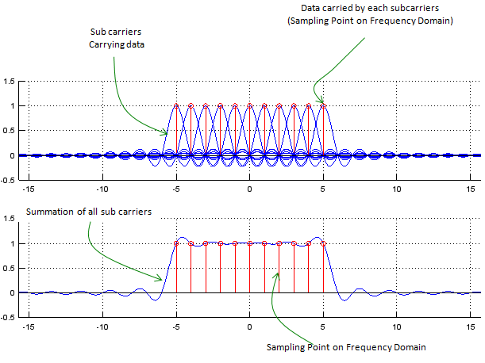
Figure 1.3

2.2.2 Multiple-Input and Multiple-Output (MIMO) and
2.2.2.1 MIMO(Multiple Input Multiple Output):
Following illustration is showing a very basic and over-simplified concept of MIMO. In very strict sense, it may be a little misleading but this can show the most common sense of MIMO concept.
As you see in the illustration, with MIMO multiple independent data streams are transmitted simultaneously and as a result it can achieve much higher data throughput in comparison to SISO (Single Input Single Output) case. However, there is almost no advantage in terms of reliability of data transfer (e.g, less error) comparing to SISO case.
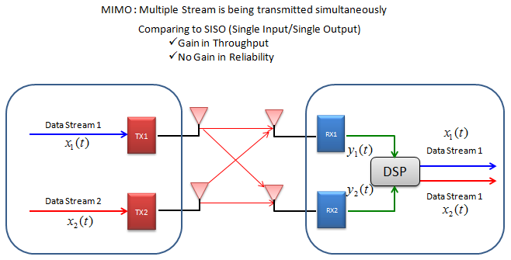
Figure 2.3
There is another concept which is often confused with MIMO. It is Diversity. What would be the difference between MIMO and Diversity ?
Following illustration would show the concept of Diversity. There are basically two types of Diversity called Receiver Diversity and Transmitter Diversity.
As you see in the illustration, in this Diversity configuration Single copy of one bit stream is being transmitted and reaches to multiple receiver antenna via a little different path, it means the receiver can have multiple versions of same data. Out of the multiple version, the receiver can select the best one or combine them all together in such a way to improve data quality. By doing this, communication reliability (less error) can be increased.. but no advantage in terms data throughput.
2.2.2.2 Beamforming :
Where MIMO is about handling multiple distinct streams or paths, Beamforming is about spatial filtering—focusing the energy of a wireless signal in a specific direction.
Instead of broadcasting a signal omnidirectionally (like a lightbulb illuminating a whole room), beamforming shapes the radiation pattern into a concentrated, directional beam (like a flashlight pointing directly at a user).
_How it Works (Phase Manipulation)
An array of closely spaced antennas transmits the same signal.
By precisely adjusting the phase and amplitude of the signal at each individual antenna element, the transmitted waves will constructively interfere (reinforce each other) in the direction of the target user.
Simultaneously, they destructively interfere (cancel each other out) in directions where other users are located, reducing interference.
Massive MIMO: In 5G, arrays with dozens or hundreds of antenna elements (Massive MIMO) are used to create highly precise, narrow beams that can track users in real-time.

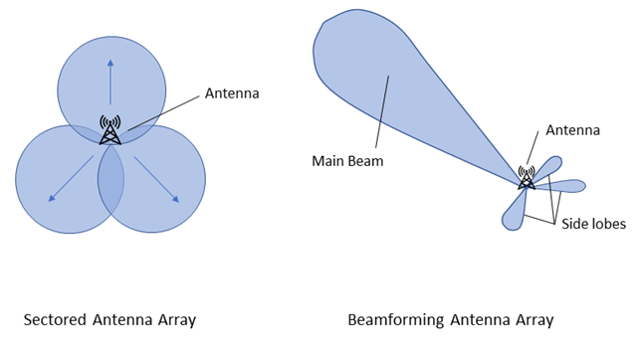
Figure 3.3

2.2.3 Spectral and Energy Efficiency:
In modern wireless communications—especially as networks transition through 5G Advanced and look toward 6G—Spectral Efficiency (SE) and Energy Efficiency (EE) have become the two most critical, and often competing, design metrics.

2.2.3.1 Spectral Efficiency (SE)
Spectral efficiency measures how effectively a wireless system utilizes its allocated frequency spectrum to transmit data. It quantified as the net information rate throughput per unit bandwidth.
$$SE=\frac{R}{B} [bits/s/Hz]$$
Where R is the data rate in bits per second (bps) and B is the bandwidth in Hertz (Hz).

Key Enablers of High SE:
_Massive MIMO & Beamforming: By utilizing large antenna arrays, gNodeBs can achieve intense spatial multiplexing. Multi-User MIMO (MU-MIMO) allows the transmission of independent data streams to multiple user equipments (UEs) simultaneously over the exact same time-frequency resources.
_Higher-Order Modulation: Moving from 256-QAM to 1024-QAM (and experimenting with 4096-QAM in short-range channels) increases the number of bits sent per symbol, though it requires a pristine Signal-to-Interference-plus-Noise Ratio (SINR).
_Flexible Numerology (5G NR): Shifting away from the rigid 15 kHz subcarrier spacing (SCS) of LTE to scalable SCS (30 kHz, 60 kHz, 120 kHz) minimizes cyclic prefix overhead and optimizes slot durations for varying channel conditions and latency requirements.

2.2.3.2 Energy Efficiency (EE):
Energy efficiency measures the performance of the network relative to its energy consumption. It can be viewed from a total network perspective or a per-link perspective, typically defined as bits transmitted per Joule of energy consumed.
$$EE=\frac{R}{P_{total}} [bits/Joule]$$
Where $P_{total}$ includes the radio frequency (RF) transmit power $P_{tx}$ plus the static hardware circuit power $P_{circ}$ consumed by baseband processing, cooling, and power amplifiers.
_Key Enablers of High EE:
_Advanced Sleep Modes (ASM): Network traffic is bursty. Modern base stations use ultra-lean design principles, dropping into deep micro-sleep states (shutting down power amplifiers and RF chains) during symbols or slots where no data is scheduled.
_Hardware and Semiconductor Evolution: Transitioning to Gallium Nitride (GaN) power amplifiers offers significantly higher power added efficiency (PAE) compared to traditional Silicon LDMOS, drastically reducing heat dissipation.
_Cell Discontinuous Transmission (DTX): Minimizing the continuous broadcasting of reference signals so that the infrastructure only consumes power when actively serving traffic.
2.2.3.3 Joint Optimization Strategies:
To avoid sacrificing one metric for the other, modern network architectures employ dynamic, algorithmic optimization:
1. Spatial Domain Optimization (Antenna Selection)
While turning on all elements of a Massive MIMO array maximizes spatial multiplexing (SE), it also scales up $P_{circ}$ linearly because every element requires a dedicated RF chain (mixers, DACs/ADCs, amplifiers). Dynamic antenna selection algorithms evaluate the channel: if user demand is low, the base station shuts down a subset of RF chains to maximize EE without severely limiting the required throughput.
2. Network Slicing and Resource Allocation
Through Network Slicing, resource allocation algorithms can be tailored to the specific Quality of Service (QoS) requirements of a slice:
eMBB (Enhanced Mobile Broadband) Slices: Prioritize high SE to sustain gigabit throughput, operating closer to the peak of the capacity curve.
mMTC (Massive Machine Type Communications) Slices: Prioritize EE, as IoT devices transmit small payloads intermittently and must conserve battery life for years.

2.3 Key Performance Indicators (Throughput, Latency, Reliability, etc.)

2.3.1 Throughput (Data Rate):
In telecommunications, throughput (often referred to as the data rate) is a measure of how much actual digital data is successfully transmitted over a network channel from a source to a destination within a specific time frame. It is typically measured in bits per second (bps), Megabits per second (Mbps), or Gigabits per second (Gbps).

2.3.2 Mathematical formula for 5G
The mathematical formula defined in 3GPP TS 38.306 serves as the definitive physical layer calculator for 5G network performance. Rather than acting as a static estimation, it functions as a dynamic multi-variable equation that calculates the absolute upper bound of a device's data-carrying capacity in real time.At its core, the formula operates by breaking down the 5G radio interface into its fundamental physical dimensions:Frequency Domain: It counts the total number of available subcarriers and resource blocks packed into the transmission channel.Time Domain: It evaluates how rapidly individual radio symbols can be transmitted based on the selected network numerology (subcarrier spacing).Spatial Domain: It scales the throughput based on the number of parallel data streams enabled by MIMO antenna arrays.Signal Quality: It Factors in the modulation depth (the number of bits encoded per radio wave cycle) and the efficiency of the error-correction coding.The data rate (expressed in Mbps) is calculated using the following summation formula over the allocated-component-carriers:
$$DataRate(Mbps)=10^{−6}\sum_{j=1}^{J}{\left(v_{Layers}^{(j)}⋅Q_{m}^{(j)}⋅f^{(j)}⋅R_{max}⋅\frac{N_{PRB}^{BW(j),μ}⋅12}{T_{s}^{μ}}⋅(1−OH^{(j)})\right)}$$
$J$: Number of aggregated component carriers.
$v_{Layers}$: MIMO layer configuration (e.g., 2 X 2 or 4 X 4).
$Q_{m}$: Modulation order (e.g., 8 for 256-QAM).
$R_{max}$: Maximum coding rate ($≈0.925$).
$N_{PRB}$: Number of allocated Physical Resource Blocks (PRBs) based on the subcarrier spacing ($μ$).
OH: Protocol overhead factor (accounts for synchronization signals, guard bands, etc.).

2.3.3 Throughput vs Bandwidth vs Goodput:
_Bandwidth: This is the theoretical maximum capacity of the pipe. For example, a 5G channel might have a maximum bandwidth of 1 Gbps under perfect laboratory conditions.
_Throughput: This is the actual amount of data pushing through that pipe in the real world. Due to physical limitations, interference, and network congestion, throughput is almost always lower than bandwidth.
_Goodput: This is a subset of throughput. It measures only the useful application-level data that reaches the user, completely excluding protocol overhead (like packet headers) and retransmitted packets.

2.3.4 Peak User Throughput:
Peak user throughput is the absolute maximum data rate achievable by a single user under ideal, flawless conditions.
Think of this as the "laboratory maximum." It represents what the technology is theoretically capable of delivering when everything goes right.
_The Scenario: A single user is standing right next to the base station (gNodeB/eNodeB) with a line-of-sight connection, zero interference from neighboring cells, no other users sharing the bandwidth, and utilizing the highest possible modulation scheme (e.g., 256-QAM or 1024-QAM) and maximum MIMO layers.
_Why it matters: It showcases the upper limit of the technology (e.g., "5G can reach 20 Gbps"). It is a crucial benchmark for marketing and for understanding the maximum capability of the hardware and spectrum.
_The Reality: Real-world users rarely experience peak throughput because networks are almost always loaded with other traffic, and environmental obstructions are common.

2.3.5 Average User Throughput:
Average user throughput (or busy-hour user throughput) is the data rate that a typical user can expect to experience across the network over time.
This is the most realistic metric for day-to-day user experience. It accounts for the fact that users are scattered at various distances from the cell tower and are sharing network resources.
_The Scenario: A mix of users at various locations (some close, some far) using the network simultaneously. It is usually calculated by taking the total data volume dropped/delivered in a cell and dividing it by the active session time of all users.
_Why it matters: This is the primary metric for network capacity planning and Quality of Experience (QoE). If a network operator wants to ensure smooth 4K video streaming for the masses, they must optimize the average throughput.
_Key Factors: It heavily depends on network loading (how many people are downloading files at the same time) and the scheduling algorithms used by the base station to distribute resources fairly.

2.3.6 Cell-Edge User Throughput :
Cell-edge user throughput is the data rate experienced by users who are far away from the cell tower, or in areas with severe signal degradation and high interference from neighboring towers.
In network engineering, this is mathematically defined as the 5th percentile (5%-tile) throughput, meaning 95% of the users in the network get a better data rate than this.
_The Scenario: A user is sitting in a basement, behind heavy concrete walls, or at the exact boundary where one cell tower's coverage ends and another begins. The signal-to-noise ratio (SINR) is incredibly low, forcing the network to drop down to robust but slow modulation schemes (like QPSK) to prevent the call or data session from dropping.
_Why it matters: This is the ultimate test of network coverage quality and uniformity. A network with high peak speeds but terrible cell-edge throughput will feel incredibly frustrating and unreliable to users as they move around.
_Engineering Focus: Modern features like Beamforming, Carrier Aggregation, and Coordinated Multipoint (CoMP) are designed specifically to boost cell-edge throughput so that service feels seamless everywhere.

2.3.7 Latency :
2.3.7.1 User-Plane (U-Plane) Latency:
User-plane latency is the time it takes to transport an application-layer packet (IP, Ethernet, etc.) across the network.
_3GPP Definition: Technically, 3GPP defines U-Plane latency as the one-way time it takes to deliver a packet from the Service Data Adaptation Protocol (SDAP) / Packet Data Convergence Protocol (PDCP) layer of the transmitter to the SDAP/PDCP layer of the receiver.
_Scope: It typically measures the air interface (RAN) delay between the User Equipment (UE) and the Next-Generation NodeB (gNB).
_Significance: This directly impacts the end-user experience for active sessions, such as real-time industrial automation, autonomous driving, or video streaming. For 5G Ultra-Reliable Low-Latency Communications (URLLC), 3GPP sets a stringent target of 1 ms for U-Plane latency.
2.3.7.2 Control-Plane (C-Plane) Latency:
Control-plane latency refers to the time required for a device to transition from an idle or power-saving state to an active data-transfer state.
_3GPP Definition: It is typically measured as the transition time from a battery-efficient state—such as RRC_IDLE or RRC_INACTIVE—to the RRC_CONNECTED state, where data transmission can actually begin.
_Scope: This involves complex signaling procedures, including Random Access (RACH), authentication, security setup, and session establishment between the UE, gNB, and the Core Network (AMF/UPF).
_Significance: While it doesn't affect packets during an active download, high C-Plane latency creates a noticeable lag when a device first wakes up to send a burst of data. 3GPP targets a C-Plane latency of sub-20 ms or sub-10 ms (depending on the specific release and deployment scenario) to ensure rapid network responsiveness for dormant devices.
2.3.7.3 One-Way Latency:
One-way latency isolates transmission performance into a single direction: Uplink (UL) (UE to network) or Downlink (DL) (network to UE).
_Why 3GPP Uses It: 3GPP explicitly uses one-way latency as its baseline requirement metric for user-plane evaluation. Because cellular networks are inherently asymmetric—utilizing different scheduling mechanisms, power constraints, and frame structures (especially in Time Division Duplexing, or TDD) for UL and DL—combining them into a single metric obscures where bottlenecks occur.
_Critical Use Cases:
_ Industrial IoT / Robotics: A sensor sending a critical telemetry alert relies entirely on ultra-low uplink one-way latency.
_Remote Driving / Haptic Feedback: A command sent to an actuator relies heavily on downlink one-way latency. If the DL is delayed, the system fails, regardless of how fast the UL was.
2.3.7.4 Round-Trip Time (RTT)
RTT measures the elapsed time from when a packet is sent from the source to when a corresponding acknowledgment or response is received back at the source.
_Application-Layer Reality: While 3GPP optimizes for one-way radio latency, the vast majority of consumer and industrial applications rely on higher-layer protocols like TCP or HTTP, which inherently require two-way handshakes. An application cannot progress until it receives confirmation of the previous packet.
_Edge Computing Impact: RTT highlights the vital role of Multi-Access Edge Computing (MEC). If a 5G network achieves a 1 ms one-way air-interface latency, but the application server is located across the globe, the internet routing path will inflate the RTT to 100+ ms, rendering the 5G latency optimizations useless. Bringing the server to the network edge minimizes the transport network component of the RTT.

2.3.8 Reliability:
In cellular network engineering, reliability is a mathematically strict, time-bound Quality of Service (QoS) metric.
According to the official 3GPP TS 22.261 (Service requirements for the 5G system) specification, network reliability is formally defined as:
"The percentage value of the amount of sent network layer packets successfully delivered to a given node within the time constraint required by the targeted service, divided by the total number of sent network layer packets."
2.3.8.1 The Mathematical Framework:
reliability (R) can be expressed as a function of the maximum allowable user-plane latency ($T_{max}$):
$$R(T_{max})=P(τ≤T_{max})=\frac{N_{success}(τ≤T_{max})}{N_{total}}$$

Where:
$τ$ is the actual end-to-end or over-the-air packet transfer delay.
$T_{max}$ is the strict time constraint (Packet Delay Budget or PDB).
$N_{success}$ is the number of packets successfully decoded before the expiration of $N_{total}$.
$N_{total}$ is the total number of injected network-layer packets.
In high-performance scenarios like Ultra-Reliable Low-Latency Communication (URLLC), engineers often track the Packet Error Rate (PER) or Block Error Rate (BLER) to evaluate the inverse of reliability:
$$PER=1−R(T_{max})$$

_3GPP Reference Requirements:
3GPP baseline requirements for reliability scale depending on the Release and the specific vertical environment (e.g., factory automation, intelligent transport, or mission-critical control).

Service Class / Use Case | Reliability Target (R) | Success / Error Probability | Time Constraint (Tmax​) | Packet Size | 3GPP Reference
Standard URLLC Baseline | $$99.999\%$$ | $$10^{−5}PER$$ | $$1ms(UserPlane)$$ | 32 Bytes | Release 15 / 16
Discrete Automation | $$99.9999\%$$ | $$10^{−6}PER$$ | $$1ms to 10ms$$ | Varying | Release 16 (Industrial IoT)
Hyper-Reliable (HRLLC) | $$99.9999999\%$$ | $$10^{−9}PER$$ | Sub-millisecond | Varying | Release 18 / 19 (Beyond 5G/6G)
 |  |  |  |  | (Beyond 5G/6G)
Table 3.3
2.3.8.2 Packet Error Rate (PER) Vs Block Error Rate (BLER):
while Packet Error Rate (PER) and Block Error Rate (BLER) both measure transmission failures, they operate at completely different layers of the network protocol stack.
_Block Error Rate (BLER):
Layer: Physical Layer (PHY).
_Definition: The ratio of incorrectly received Transport Blocks (TBs) to the total number of transmitted Transport Blocks over the radio interface.
_Mechanism: When the Upper Layers pass a network packet down to the Physical Layer, it is segmented into one or more Transport Blocks. A Cyclic Redundancy Check (CRC) bits are attached to each block. If the receiver's hardware calculates a CRC mismatch, a block error is declared, triggering a rapid physical-layer retransmission (HARQ).
_Engineering Purpose: Used for real-time radio link adaptation. The base station (gNB) monitors BLER to dynamically adjust modulation and coding schemes (MCS) or transmission power. A typical target for standard traffic is a BLER of $10\% (10^{−1})$ before retransmissions.
2.3.8.3 Packet Error Rate (PER):
_Layer: Network Layer / PDCP Layer.
_Definition: The ratio of incorrectly received or completely lost Network Layer Packets (e.g., IP packets) to the total number of transmitted packets.
-Mechanism: A single network packet is often larger than a transport block. If any single underlying transport block fails definitively after all radio-level retransmission attempts (HARQ) are exhausted, the entire upper-layer packet becomes corrupted or incomplete.
_Engineering Purpose: Used to measure end-to-end Quality of Service (QoS) and user experience. For applications like URLLC, the target PER is incredibly stringent (e.g., $10^{−5}or99.999\%$ reliability) within a strict time boundary.
_Mathematical Relationship:
Because a single network packet is fragmented into multiple transport blocks, BLER and PER are mathematically linked, but they are not identical.
If a network packet is segmented into N independent transport blocks, and each block has an average block error probability ($P_{b}$), the packet error rate ($P_{p}$) can be modeled as:
$$P_{p}=1−(1−P_{b})^{N}$$

This formula highlights a crucial rule of thumb: If even one transport block fails completely, the entire packet is lost. Therefore, if a packet spans multiple blocks, the Packet Error Rate will generally be higher than the individual raw Block Error Rate before retransmissions.

2.3.9 Packet Loss Ratio
The Packet Loss Ratio is a network-layer metric that quantifies the fraction of transmitted packets that fail to reach the ingress buffer of the destination node.
Mathematically, it is expressed as:
$$PLR=\frac{N_{tx}−N_{rx}}{N_{tx}}$$
Where $N_{tx}$is the total number of transmitted packets and $N_{rx}$ is the number of packets successfully received at the destination.
_Primary Mechanism: PLR is predominantly driven by network layer congestion. When traffic volume exceeds the switching fabric capacity or the egress queuing capacity of an intermediate routing node, buffer overflow occurs. Consequently, routers execute active queue management (AQM) policies (e.g., Tail Drop, Random Early Detection) and discard transient packets.
_Routing Issues: A link goes down, or a routing loop occurs, causing packets to time out and get dropped.
_Analogy: You mail 100 letters, but 5 of them are completely lost by the post office and never delivered to the recipient's mailbox. Your packet loss ratio is 5%.

2.3.10 Connection Density:
Connection density is the total number of connected and/or active devices per unit area that fulfill a targeted Quality of Service (QoS) requirement, such as a specified packet delivery success rate within a defined maximum latency window.
_Mathematical Representation:
At an analytical level, connection density is modeled as the ratio of total successfully accommodated device endpoints to the total target coverage deployment area:
$$ρ_{conn}=\frac{N_{dev}}{A}$$
Where:
$ρ_{conn}$ represents the connection density.
$N_{dev}$ denotes the total number of concurrently connected infrastructure devices meeting network operational thresholds.
A specifies the unit area, formally designated in square kilometers (${km}^{2}$).

2.3.10.1 Comparison:
Network Paradigm | Target Connection Density Benchmark | Primary Technical Focus
Legacy 4G LTE | ~10,000 to 100,000 ${devices/km}^{2}$ | Human-centric data streams, voice, and high-speed mobile broadband (IMT-Advanced).
5G NR (mMTC) | $≥$ 1,000,000 ${devices/km}^{2}$ | Massive scaling of low-power, low-throughput IoT endpoints (IMT-2020).
6G Architecture | $≥$10,000,000 to 100,000,000 ${devices/km}^{2}$ | Ultra-dense cyber-physical networks, global smart city automation, and ambient intelligence.

Table 4.3

2.3.11 Mobility:
In mobile telecommunications, mobility management is the framework that ensures a user equipment (UE)—like a smartphone or a connected vehicle—maintains a seamless, high-performance connection while moving across different cells at varying speeds.
When a user moves, the wireless channel constantly fluctuates due to distance, obstacles, and physical speed. Maintaining performance requires a complex interplay between the device and the network core.
As velocity increases, the physics of radio wave propagation introduce severe impairments that the network must continuously mitigate:
Doppler Shift and Spread: As a device moves faster relative to a cell tower, the frequency of the received signal shifts (Doppler shift). High speeds cause rapid, random fluctuations in the phase and amplitude of the signal (Doppler spread). This destroys the orthogonality of multi-carrier systems like OFDM, leading to Inter-Carrier Interference (ICI).
Fast Fading (Rayleigh/Rician Fading): At high speeds, the device passes through constructive and destructive interference patterns of the radio wave within milliseconds. This causes deep, rapid drops in signal strength.
Penetration and Path Loss: At high speeds (e.g., inside a high-speed train or a vehicle), the signal must penetrate metallic hulls, causing sharp drops in the Signal-to-Interference-plus-Noise Ratio (SINR).

2.3.11.1 Mobility Mechanisms Across Speed Tiers:
Mobility Tier | Speed Range | Key Challenge | Primary Mobility Strategy
Pedestrian / Stationary | $$0−10km/h$$ | Shadowing, localized fading | Standard RSRP/RSRQ reporting, high-order modulation (256QAM).
Medium / Urban | $$10−50km/h$$ | Frequent cell boundary crossings | Normal handover evaluation with optimized Time-to-Trigger (TTT).
High Speed / Highway | $$50−120km/h$$ | Fast fading, Doppler spread | Scaled-down TTT, increased reference signal frequency, beam tracking.
Ultra High Speed / Rail | $$120−500+km/h$$ | Handover failure, severe ICI | Conditional Handover (CHO), high-density DMRS, Dual Connectivity.
Table 5.3

2.4 -5G System Architecture and Usage Scenarios (eMBB, URLLC, mMTC):

2.4.1 Core Network Architecture (EPC vs. 5G Core):
2.4.1.1 Architectural Philosophy: Point-to-Point vs. Service-Based:
The structural differences between EPC and 5GC lie in how network functions (NFs) interact with one another.
-Evolved Packet Core (EPC)
EPC is built on a Point-to-Point architecture. Each network element—such as the Mobility Management Entity (MME), Serving Gateway (S-GW), and Packet Data Network Gateway (P-GW)—is interconnected via rigid, explicitly defined interfaces (e.g., S11, S5/S8) specified by the 3GPP.
_Characteristics: Elements are often deployed on dedicated, proprietary hardware. Scaling a specific function or introducing a new network element requires modifying these discrete physical or logical interfaces, resulting in a relatively inflexible topology.
_5G Core (5GC)
The 5GC replaces rigid interfaces with a Service-Based Architecture (SBA). In this framework, network functions are decomposed into modular, self-contained services that exhibit loose coupling.
_Characteristics: NFs communicate over a common internet protocol bus using lightweight application programming interfaces (APIs), typically utilizing HTTP/2 or HTTP/3 over JSON. Instead of hardcoded paths, an NF registers its capabilities with a Network Repository Function (NRF), allowing other authorization-cleared NFs to dynamically discover and invoke its services. This brings web-scale cloud computing flexibility to the cellular core.
2.4.1.2 Functional Decomposition and Control/User Plane Separation:
Optimizing data routing requires separating the protocols that control the network from the actual user payload.
_Control and User Plane Split:
_In EPC: Control and User Plane Separation (CUPS) was introduced late in 3GPP Release 14 as an enhancement, but the baseline EPC tightly binds control and user data processing. The S-GW and P-GW handle both signaling and traffic encapsulation. Consequently, if user data volume scales exponentially, the control signaling capacity must often be scaled in tandem, leading to inefficient resource allocation.
_In 5GC: CUPS is baked into the foundation from day one. The control plane is entirely isolated from the user plane.
The AMF (Access and Mobility Management Function) and SMF (Session Management Function) inherit and divide the control plane responsibilities of the legacy MME.
The UPF (User Plane Function) becomes the solitary, highly streamlined engine responsible for packet routing, forwarding, and encapsulation
2.4.1.3 Core Functional Mapping:
The architectural evolution can be mapped directly through the structural evolution of these core network components:

Functional Responsibility | 4G EPC Element | 5G Core (5GC) Equivalent
Mobility & Authentication | MME | AMF (Access and Mobility Management Function)
Session & IP Management | MME / S-GW / P-GW | SMF (Session Management Function)
User Plane Routing / Anchor | S-GW / P-GW | UPF (User Plane Function)
Subscriber Data Storage | HSS | UDM (Unified Data Management) / UDR
Policy Control & Charging | PCRF | PCF (Policy Control Function)
Table 2.3
2.4.1.4 Network Slicing and Service Customization:
One of the most significant advancements of the 5G Core is its native support for network slicing, a capability that was highly constrained in legacy architectures.
In 4G EPC
EPC utilizes a feature called DECOR (Dedicated Core) or eDECOR to route specific users to specific core network elements based on subscription profiles. However, this is an overlay mechanism rather than an intrinsic design element; it lacks the granular, end-to-end orchestration needed to dynamically instantiate and isolate virtual pipelines.
In 5G Core
Network slicing is an architectural pillar in 5GC. Guided by the NSSF (Network Slice Selection Function), the core network can instantiate multiple virtual, logically isolated end-to-end networks over a shared physical infrastructure.
_Each slice can be tailored to distinct Performance Indicators (KPIs):
_eMBB (Enhanced Mobile Broadband): Allocates high-throughput UPFs at centralized data centers for massive data pipelines.
_uRLLC (Ultra-Reliable Low-Latency Communications): Pushes deterministic, low-overhead UPFs right to the network edge, minimizing propagation delay.
_mMTC (Massive Machine-Type Communications): Provisions energy-optimized control planes capable of managing millions of sporadic, low-throughput IoT connections without overwhelming signaling registers.

2.4.2 Key Drivers and Usage Scenarios (eMBB, URLLC, mMTC):
5G will enable instantaneous connectivity to billions of devices, the Internet of Things (IoT), and a truly connected world. 5G will provide the speed, low latency, and connectivity to enable a new generation of applications, services, and business opportunities that have not been seen before. There are three major categories of use case for 5G and also as shown in figure (1.1):

2.4.2.1 Enhanced mobile broadband:
providing significantly faster data speeds and greater capacity keeping the world connected. New applications will include fixed wireless internet access for homes, outdoor broadcast applications without the need for broadcast vans, and greater connectivity for people on the move.
_ KPIs that it set by ITU are :
_Peak Data Rate: Downlink up to 20 Gbps; Uplink up to 10 Gbps.
_User Experienced Data Rate: Consistent 100 Mbps in urban/dense environments.
_Area Traffic Capacity: $10{Mbps/m}^{2}$.
_And it can be achieved through :
_Spectrum Expansion: Utilization of Mid-Band (C-band) and High-Band/millimeter Wave (mmWave) frequencies to access wider channel bandwidths (up to 400 MHz).
_Massive MIMO: Deploying dense antenna arrays (e.g., 64T64R) at the gNodeB to support advanced spatial multiplexing and beamforming, which concentrates energy directly toward the user device.
_Advanced Modulation: Implementing 256-QAM (and up to 1024-QAM in close-range scenarios) to pack more bits per hertz.
2.4.2.2 Ultra-reliable low latency communications:
mission-critical including real-time control of devices, industrial robotics, vehicle to vehicle communications and safety systems, autonomous driving, and safer transport networks. Low latency communications also open up a new world where remote medical care, procedures, and treatment are all possible.
_KPIs that it set by ITU are :
_User-Plane Latency: $≤1ms$ over the radio access network (RAN).
_Reliability: Success probability of $99.999\%$to$99.9999\%$ (often framed as
$1−10^{−5} or 1−10^{−6}$ Block Error Rate).
_And it can be achieved through :
_Flexible Numerology & Short TTI: Scalable subcarrier spacing (SCS) up to 60 kHz or 120 kHz, which shrinks the Transmission Time Interval (TTI) into mini-slots, allowing data to be transmitted immediately without waiting for a standard 1 ms slot boundary.
_Edge Computing (MEC): Pulling user-plane processing (UPF) functions and application servers closer to the network edge, drastically reducing propagation delays over the backhaul network.
_Grant-Free Uplink: Eliminating the traditional request-and-grant handshake between the device and base station, devices can transmit uplink data instantly on pre-allocated resources.
_Packet Duplication (PDCP Level): Sending identical packets across multiple independent RF paths or carrier frequencies simultaneously to guarantee delivery.
2.4.2.3 Massive to machine communications
also called the Internet of Things (IoT) that involves connecting billions of devices without human intervention at a scale not seen before. This has the potential to revolutionize modern industrial processes and applications including agriculture, manufacturing, and business communications.
KPIs that it set by ITU are :
Connection Density: Up to $1,000,000{devices/km}^{2}$ (a 10x increase over 4G).
Battery Life: $≥10years$ of operation on a standard AA battery without recharging.
Coverage Link Budget: $20dB$ enhancement over legacy GSM/GPRS systems.
And it can be achieved through :
Narrowband Waveforms (NB-IoT & LTE-M Integration): Operating within narrow bandwidths (as low as 180 kHz) to concentrate power spectral density, which improves signal penetration deep indoors or underground.
Power Saving Mechanisms: Utilizing Extended Discontinuous Reception (eDRX) and Power Saving Mode (PSM), allowing devices to remain sleep for hours or days, checking the network only during scheduled windows.
Efficient Small-Packet Transmission: Tailoring MAC and RRC layers to transmit tiny bursts of uplink data with minimal signaling overhead, preventing network congestion.

2.4.3 Overall 5G System Architecture: A High-Level View:
Schematically, the 5G system uses the same elements as the previous generations: a User Equipment (UE), itself composed of a Mobile Station and a USIM, the Radio Access Network (NG-RAN) and the Core Network (5GC), as shown in the figure below
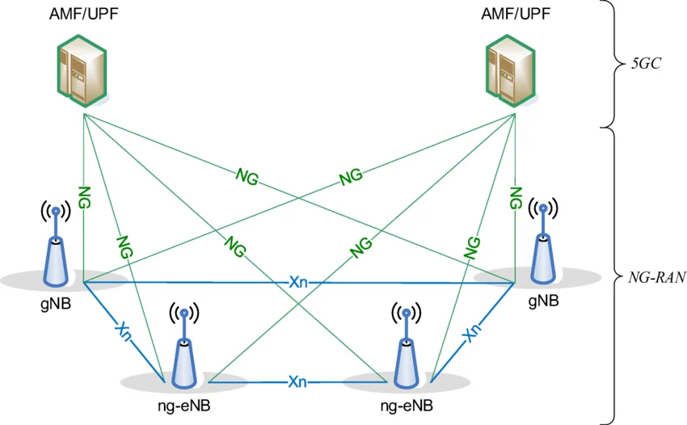
Figure 4.4
The main entity of the NG-RAN is the gNB, where "g" stands for "5G" and "NB" for "Node B", which is the name inherited from 3G onwards to refer to the radio transmitter. The radio interface is named "NR-RAN" for similar reasons, although with divergences: here, "5G" is indicated by "NR" (for "New Radio") and RAN is also a name inherited from previous generations.
The 5GC is here schematically represented by the AMF/UPF entity: the User Plane Function (UPF), handling the user data and, in the signalling plane, the Access and
Mobility management Function (AMF) that accesses the UE and the (R)AN. Further entities of the 5GC are presented below. The reference point between the access and the core networks is called "NG".
The 5GC architecture relies on a "Service-Based Architecture" (SBA) framework, where the architecture elements are defined in terms of "Network Functions" (NFs) rather than by "traditional" Network Entities.
Via interfaces of a common framework, any given NF offers its services to all the other authorized NFs and/or to any "consumers" that are permitted to make use of these provided services. Such an SBA approach offers modularity and reusability

2.4.4 The Service-Based Architecture (SBA) of the 5G Core:
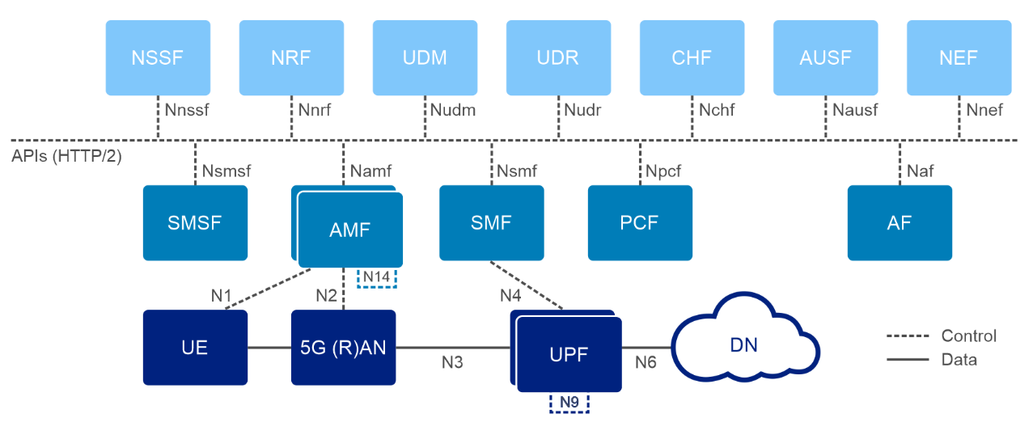
Figure 5.4
In the figure above, the User Plane, i.e. the Network Functions (NFs) and elements involved in the transport of user data, is shown at the bottom level, whereas the upper part of the figure shows all the essential NFs within the signalling plane.
The Core Split:
_The User Plane: This is the simplified highway where your actual data traffic travels. It has only one major checkpoint in the core network: the User Plane Function (UPF). The UPF acts like a high-speed sorting warehouse, routing your internet traffic directly to its destination with as little delay as possible.
_The Control Plane: This is the corporate office. It manages authentication, coordinates cell tower handoffs, and establishes connections, but it never touches your actual web-browsing data.
Items of the SBA:
Instead of dedicated hardware boxes, the 5G Control Plane is built like a collection of microservices running in a cloud data center. These Network Functions (NFs) don't use old telecom wires to talk; they use an internal "Service Bus" running standard web protocols (HTTP/2 APIs).
_AMF : The Access and Mobility Management Function is the first point of contact. When your phone turns on, it talks to the AMF. The AMF verifies who you are and tracks which cell tower you are currently using.
_SMF: The Session Management Function handles the data pathways. Once the AMF lets you in, the SMF gives your phone an IP address and instructs the UPF on exactly how to route your traffic.
_UDM & AUSF: The Unified Data Management (UDM) holds your subscription profile, while the Authentication Server Function (AUSF) validates your SIM card's security keys.
_PCF : The Policy Control Function determines your network rules—like your maximum data speeds or network priority status.
_NRF : Because these software functions spin up and down dynamically in the cloud, the Network Repository Function acts as an automated phonebook so the apps can discover each other instantly.

2.4.5 The 5G New Radio (NR) Access Network:
The 5G New Radio (NR) Access Network, standardized by 3GPP, represents a complete overhaul of the wireless interface and radio access architecture compared to 4G LTE. It is engineered not just for higher throughput, but to natively support highly diverse service profiles: eMBB, URLLC , and mMTC.
2.4.5.1 Architecture & Nodes:
The 5G RAN—referred to as the Next-Generation Radio Access Network (NG-RAN)—introduces new logical nodes and standardized interfaces to separate control and user planes cleanly.
_Key Nodes:
_gNodeB (gNB): The primary base station in 5G NR that provides the NR user plane and control plane protocol terminations toward the User Equipment (UE).
_ng-eNodeB (ng-eNB): An evolved 4G LTE base station that can connect to the 5G Core (5GC) network, allowing legacy LTE frequencies to be integrated into the 5G ecosystem.
_Standardized Interfaces:
_NG Interface: The boundary between the NG-RAN and the 5G Core (5GC).
_NG-C (Control Plane): Connects the gNB to the Access and Mobility Management Function (AMF).
_NG-U (User Plane): Connects the gNB to the User Plane Function (UPF) for data routing.
_Xn Interface: Connects neighboring base stations (gNB-to-gNB or gNB-to-ng-eNB) to facilitate ultra-fast handovers, dual connectivity, and RAN-level paging
2.4.5.2 Disaggregated gNB & Functional Splits:

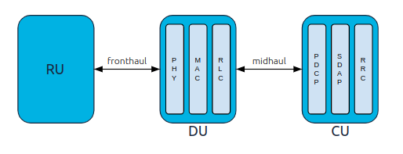
Figure 6.4

To support cloud-native deployments (vRAN/Cloud-RAN) and optimize cost versus performance, 3GPP disaggregated the traditional monolithic base station into logical components using the Option 2 High-Layer Split (HLS) and lower-layer splits.
_ Central Unit (CU):
The CU handles non-real-time, high-layer protocols. It is further split via the E1 interface into:
CU-Control Plane (CU-CP): Hosts the Radio Resource Control (RRC) and the control plane part of the Packet Data Convergence Protocol (PDCP).
CU-User Plane (CU-UP): Hosts the Service Data Adaptation Protocol (SDAP)—which maps QoS flows to radio bearers—and the user plane part of PDCP.
Distributed Unit (DU):
The DU handles real-time, time-critical protocol layers. It hosts:
Radio Link Control (RLC)
Medium Access Control (MAC)
The upper portions of the Physical Layer (High-PHY), such as channel coding and modulation.
Radio Unit (RU)
The RU handles the Low-PHY functions (Fast Fourier Transforms, beamforming weights execution) and RF conversion. In modern deployments (like O-RAN), it connects to the DU over an eCPRI-based open fronhaul using a lower-layer split point.

2.5 Enabling Technologies (Network Slicing, SDN, NFV, MEC, mmWave):

2.5.1 Network Slicing:
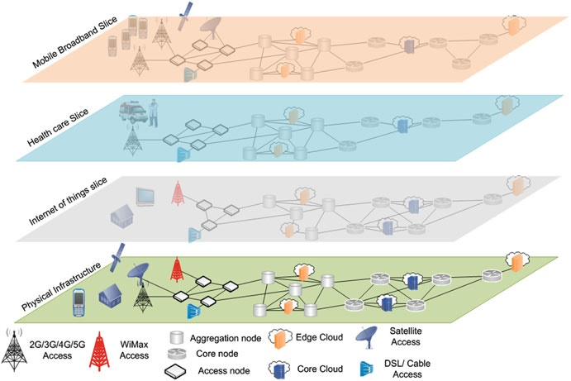
5G networks are intended to provide mainly three types of services: (mMTC), (URLLC), and (eMBB).
The mMTC is characterized by massive number of devices communicating with each other and requires low cost along with long battery backup time.
Apart from that, URLLC need simultaneous low latency and ultra-reliability. On the other hand, eMBB requires higher data rates along with large coverage area.
To enable users with eMBB, mMTC, and URLLC, it’s imperative to redesign the network architecture.
Network slicing is a promising candidate to allow 5G networks to offer a wide variety of services and applications such as e-health, augmented reality, smart transportation system, smart banking, smart farming, and mobile gaming.
The notion of the network slicing is to leverage the network infrastructure resources for creation of multiple subnetworks for different types of services and applications. Then, each subnetwork will perform slicing of the physical network resources to yield an independent network for its applications.
To enable different 5G services, slices of different types for mMTC, URRLC, and eMBB services that utilize the network resources can be created.
We can assign each slice type with complete end-to-end network resources; however, it does not seem practical because of the high expense.
On the other hand, it would be feasible to allow sharing of the network resources among multiple types of slices using technologies like network function virtualization and software defined networking.
The notion of network slicing is the virtual network architecture that will enable powerful and flexible capability of creating multiple logical networks on top of the common physical infrastructure as illustrated in figure 7.5
Figure 7.5
Network softwarization is an emerging concept that will enable the network slicing using software-based solutions.
it can be achieved through technologies such as Network Function Virtualization (NFV) and Software Defined Networking (SDN).
Specifically, network slicing in 5G will use SDN, NFV, cloud computing, and edge computing to enable flexible operation for different types of services over the same physical infrastructure.
Network slicing allows the creation of logical networks for different types of services as illustrated in Figure (2.1).
Each logical network will have independent control with the ability of creation on demand .
A generic framework for 5G network slicing is presented as shown in Figure (2.2).
This framework has three layers such as service layer, network function layer, and infrastructure layer. Apart from these three layers, it contains Management and Orchestration (MANO) entity. The MANO performs the translation of service models and use cases into slices. The network infrastructure layer deals with the physical network infrastructure that covers both core network and radio access network. Other than this, the infrastructure layer also performs infrastructure control and allocation of resources to the slices. Apart from infrastructure layer, the network function layer performs the encapsulation of the operations required in network functions configuration and life cycle management. These network functions are then chained together to deliver an end-to-end service
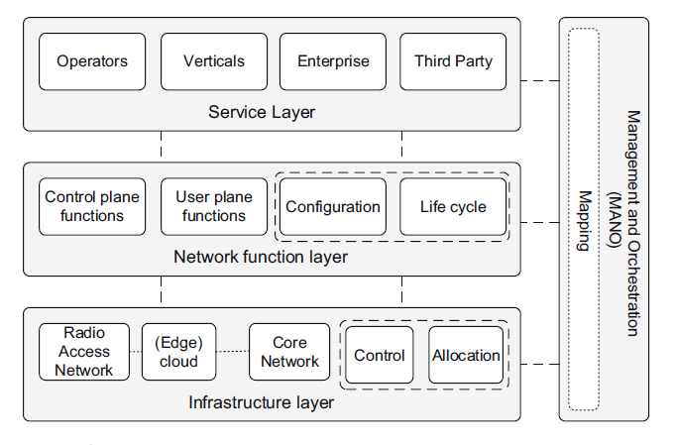
Figure 8.5
2.5.2 Software-Defined Networking (SDN):
Software-Defined Networking (SDN) is a modern network architecture that transforms how we manage and operate networks.Traditionally, networking hardware like switches and routers operated as standalone, autonomous units. They had to make their own decisions about where to send traffic while simultaneously forwarding that traffic. SDN shatters this model by separating the brains from the brawn.the two distinct types of logic running inside traditional networking hardware: the Control Plane and the Data Plane.The Control PlaneThe control plane is responsible for network signaling and routing decisions. It determines the path that data packets should take across the network topology.It’s Running routing protocols (like OSPF, BGP, or EIGRP), building routing tables, maintaining topology maps, and configuring ACLs (Access Control Lists).The Data Plane.Also known as the Forwarding Plane, the data plane is responsible for the actual movement of data packets from an input interface to an output interface, based on the instructions provided by the control plane.Functions: Packet switching, MAC address lookups, IP header validation, and pushing packets out of specific physical ports.The core innovation of SDN is how these planes are structured across the network.Traditional Networks: Distributed ControlIn a traditional network, every single switch and router contains its own control plane and data plane. Because the control plane is distributed, devices must constantly talk to their neighbors using complex protocols to agree on the network topology. If you need to implement a new policy or change a route, you often have to log into dozens or hundreds of individual devices to configure them manually via a Command Line Interface (CLI).SDN Networks: Centralized ControlSDN decouples these two planes. It strips the control plane (the intelligence) out of the individual hardware switches and centralizes it into a software application known as the SDN Controller.The physical switches become "dumb" forwarding devices that only contain the data plane. They no longer make routing decisions; they simply follow the explicit forwarding instructions pushed down to them by the centralized controller. 2.5.3 Network Functions Virtualization (NFV):Network functions virtualization (NFV) takes modern networks one step closer to the cloud, making the deployment and management of network functions, services and applications completely virtual.NFV is a modern network architecture approach that decouples the network’s various applications from its hardware resources including compute, storage and other network hardware. This creates a virtualized layer of network functions deployed as virtual machines (VMs) or containers that can be shared by all network applications.Core Architecture: The ETSI NFV FrameworkThe European Telecommunications Standards Institute (ETSI) defined the standard NFV architecture, which is divided into three primary domain blocks:1. Virtual Network Functions (VNFs)A VNF is the software implementation of a specific network service. Rather than buying a physical firewall unit, an organization deploys a VNF firewall image onto a server cluster. Multiple VNFs can be chained together (service chaining) to process data traffic sequentially.2. NFV Infrastructure (NFVI)NFVI represents the totality of hardware and software resources that form the environment in which VNFs are deployed:Hardware Resources: Standard x86 servers, physical storage arrays, and network switches.Virtualization Layer: Hypervisors (like KVM or VMware ESXi) or container engines (like Docker/Kubernetes) that abstract physical hardware into virtual compute, storage, and networking pools.3. NFV Management and Orchestration (MANO)MANO handles the lifecycle management and provisioning of all virtual resources and network functions:Orchestrator (NFVO): Manages end-to-end network service creation and global resource management across the infrastructure.VNF Manager (VNFM): Handles the lifecycle operations (instantiation, scaling, updates, fault recovery) of individual VNF instances.Virtualized Infrastructure Manager (VIM): Controls and manages the compute, storage, and network resources within the NFVI (e.g., OpenStack, Kubernetes).NFV vs SDNWhile often deployed together, NFV and Software-Defined Networking (SDN) solve different problems:

Attribute | Network Functions Virtualization (NFV) | Software-Defined Networking (SDN)
Primary Goal | Replace dedicated hardware appliances with software running on standard servers. | Separate the network control plane from the data forwarding plane.
Focus | Layer 4 through Layer 7 services (Firewalls, NAT, Load Balancers, EPC/5G Core). | Layer 2 through Layer 3 packet routing and traffic flow management.
Key Component | Virtual Network Functions (VNFs) and Hypervisors/Containers. | Centralized SDN Controller (e.g., OpenFlow, P4).
Table 6.5

2.5.4 Edge Computing and Multi-access Edge Computing (MEC):
Edge computing shifts data processing, storage, and logic from centralized cloud data centers directly to the periphery of the network—near where data is generated. Multi-access Edge Computing (MEC) is an ETSI-standardized framework that brings edge computing specifically into telecommunications networks.
_Why MEC Matters in 5G Networks?
In traditional mobile networks, every byte of data sent from a smartphone or IoT device must travel through base stations back to a centralized Core Network and then out to the internet. This introduces physical distance latency $(30–100ms)$.
MEC changes this by placing cloud-like servers right at the cellular edge. It introduces Local Breakout (LBO) via the 5G User Plane Function (UPF), steering latency-sensitive traffic locally before it ever reaches the core internet.
_Ultra-Low Latency: Cuts round-trip time down to sub-10 milliseconds, essential for real-time applications.
_Bandwidth Optimization: Aggregates and filters massive data streams locally (e.g., video security feeds) so only essential data hits the backhaul network.

2.5.5 Massive MIMO and Advanced Beamforming Techniques:
Massive MIMO (Multiple-Input Multiple-Output) and Advanced Beamforming are core foundational technologies behind modern 5G NR (New Radio) and upcoming 6G networks.
While traditional MIMO uses a small number of antennas (e.g., 2×2 or 4×4), Massive MIMO equips base stations with large-scale antenna arrays—typically 32, 64, or 128 elements (and up to 256 or 512 in millimeter-wave bands). This allows
base stations to serve multiple users simultaneously over the same frequency channel through spatial multiplexing.
Instead of broadcasting radio signals uniformly across a wide sector, beamforming uses phase and amplitude adjustments across individual array elements to construct precise, directional RF beams focused directly toward target devices.
_Constructive Interference: Signal waves from each antenna element arrive at the target receiver in phase, boosting signal power (high Signal-to-Noise Ratio).
_Destructive Interference: Waves arrive out of phase in unwanted directions, creating nulls that eliminate inter-user interference.
Modern base stations choose between three main physical implementations based on power consumption, hardware cost, and performance demands:

Architecture | Description | Pros | Cons
Analog Beamforming | Applies phase shifts at the RF stage using a single transceivers chain per subarray. | Low hardware cost and power consumption. | Can only form a single narrow beam per array at a time.
Digital Beamforming | Applies signal processing to each individual antenna element in the baseband. | Full spatial flexibility; creates unlimited simultaneous independent beams. | High cost, high computational load, and high RF power consumption.
Hybrid Beamforming | Combines baseband digital precoding with analog RF phase shifters. | Optimal balance between energy efficiency, cost, and spatial flexibility (standard in mmWave). | Complex calibration between digital and analog layers.
Table 7.5

2.5.6 Millimeter Wave (mmWave) Spectrum:
Millimeter Wave (mmWave) refers to the high-frequency band of the radio frequency spectrum roughly between 30 GHz and 300 GHz. In cellular communications (like 5G 3GPP FR2 standard), the range starting around 24 GHz is also commonly included under the mmWave umbrella.
Core Characteristics
Massive Bandwidth & Speed: Because it sits at high frequencies, mmWave provides massive continuous chunks of ungested spectrum. This allows multi-gigabit data transfer speeds (2–10+ Gbps) and ultra-low latency.
Short Propagation Range: High-frequency signals lose energy quickly in the atmosphere. Effective coverage ranges from a few hundred meters down to a single room.
_Poor Physical Penetration: mmWave signals cannot easily pass through solid barriers like concrete walls, glass, foliage, or human bodies. They are also susceptible to atmospheric conditions, like heavy rain ("rain fade").
To overcome short ranges and attenuation, mmWave relies on several advanced RF technologies:
_Beamforming: Concentrates RF energy into narrow, focused directional beams pointed toward specific user devices instead of broadcasting in all directions.
_Massive MIMO: Packs dozens or hundreds of micro-antennas into small arrays on base stations and inside mobile devices.
_Small Cells: Uses dense networks of small, low-power nodes mounted on streetlights, utility poles, and building corners rather than huge cell towers.

2.6 Related Work
In summary, this chapter reviewed the evolution of mobile networks from 1G to 6G, presented fundamental wireless concepts, defined key performance indicators, described the 5G system architecture and usage scenarios, and discussed enabling technologies including network slicing, SDN, NFV, MEC, and mmWave. These foundations provide the necessary context for the simulation-based methodology presented in the following chapter.
Several studies have explored 5G network performance in industrial environments. Ochonu and Vidal (2024) investigated slice-aware resource allocation and admission control for smart factory wireless networks, highlighting the challenges of meeting diverse QoS requirements simultaneously. Zanbouri et al. (2025) analyzed the scalability of 5G-TSN applications in indoor factory settings, demonstrating the impact of deployment scenarios on network performance. Rafique et al. (2024) surveyed beyond-5G network slicing for smart city applications, providing insights into the evolution of slicing architectures. These works collectively emphasize the importance of simulation-based evaluation for 5G industrial deployments and motivate the design approach adopted in this project.

Chapter 3
Research Methodology, Project Analysis and Design

This chapter presents the research methodology adopted for this project. It discusses the role of simulation in network design, justifies the selection of OMNeT++ with Simu5G, describes the simulation setup and topology design for the industrial factory environment, details the configuration parameters for two scenarios, and defines the traffic models used for static, mobile, and TCP-based applications.

3.1 Role of Simulation in Network Design and Analysis:
Computer simulation plays a pivotal role in the design, evaluation, and optimization of modern telecommunication networks. Deploying and testing 5G infrastructure in real-world environments is often economically unfeasible, time-consuming, and technically challenging due to high equipment costs and dynamic radio propagation environments. Network simulators provide a controlled, flexible, and cost-effective environment to evaluate system performance under diverse traffic loads, user mobility profiles, and channel conditions.
Furthermore, simulation enables researchers to analyze critical performance metrics—such as throughput, end-to-end latency, packet delivery ratio, and resource utilization—prior to actual deployment. It also allows for the safe experimentation of novel protocols and resource management algorithms without disrupting operational networks.3.2 Simulator Selection and Justification (OMNeT++ / Simu5G):
Selecting an appropriate simulation environment is essential for obtaining reliable research results. Several discrete-event network simulators are widely adopted in academia and industry for modeling wireless networks:
NS-3 (Network Simulator 3): An open-source, discrete-event network simulator written in C++ with optional Python bindings. NS-3 is highly regarded for its detailed protocol implementations and accurate channel models. However, it relies heavily on command-line interfaces and script-based configurations, which can increase complexity during topology visualization and debugging.
OMNeT++: An extensible, component-based C++ simulation framework featuring a modular architecture and a rich Graphical User Interface (GUI). OMNeT++ utilizes the Network Description (NED) language to define network topologies, separating the structural design from the underlying C++ protocol behaviors. When combined with specialized domain libraries (such as INET and Simu5G), it provides a comprehensive platform for end-to-end cellular network simulation.

3.2.1 Justification for Simulator Selection for this Project
For the implementation and performance evaluation of the proposed 5G network architecture in this project, OMNeT++ was selected as the primary simulation tool, integrated with the Simu5G library and the INET framework. The rationale behind this selection includes the following key factors:
_Comprehensive 5G Support (Simu5G Integration): OMNeT++ natively integrates with Simu5G, a dedicated library designed to model 5G New Radio (NR) user equipments (UEs), next-generation NodeBs (gNodeBs), and the 5G Core (5GC).
_Modular Architecture (NED Language): The clear separation between network topology design (via NED files) and execution logic (via C++) enables rapid prototyping, clear modularity, and easy parameter adjustments for different experimental scenarios.
_Advanced GUI and Visualization: OMNeT++ offers superior graphical visualization tools, allowing real-time tracking of packet flows, node mobility, and network events. This facilitates efficient debugging and intuitive analysis of performance bottlenecks.

3.2.2 Key Simulation Parameters for Modeling a 5G Network

3.3 Simulation Setup and Topology Design:

3.3.1 Introduction:
This chapter presents the implementation of the proposed 5G smart factory simulation using OMNeT++. It describes the process of creating the simulation project, designing the network topology, configuring the simulation parameters, and defining the traffic generated by the industrial devices. Finally, the performance metrics used to evaluate the network are introduced before presenting the simulation results.

3.3.2 Software Tools and Simulation Frameworks
The proposed 5G smart factory simulation was developed using OMNeT++ together with the INET and Simu5G frameworks. These software tools complement each other and provide the necessary components required to model, configure, and evaluate a complete 5G communication network.
OMNeT++ serves as the main discrete-event simulation environment. It provides the infrastructure for designing the network topology, executing simulation scenarios, visualizing the network operation, and collecting performance results.
The INET framework extends OMNeT++ by providing standard communication protocols, network devices, mobility models, and application-layer traffic generators. It supplies components such as routers, hosts, Ethernet links, IPv4 configuration, and TCP/IP protocols, which are required to build the backbone of the factory communication network.
The Simu5G framework extends OMNeT++ with a complete implementation of 5G New Radio (NR) networks. It provides essential 5G components, including the gNodeB, NR User Equipment (NR UE), User Plane Function (UPF), radio channel models, carrier aggregation, scheduling mechanisms, and other radio access network functionalities. These features enable realistic simulation of industrial 5G communication scenarios.
The integration of OMNeT++, INET, and Simu5G provides a comprehensive simulation platform capable of modeling both the core network and the 5G radio access network. This combination allows the proposed smart factory scenario to be implemented and evaluated under realistic communication conditions.
3.3.3 Setting Up the Project in OMNeT++
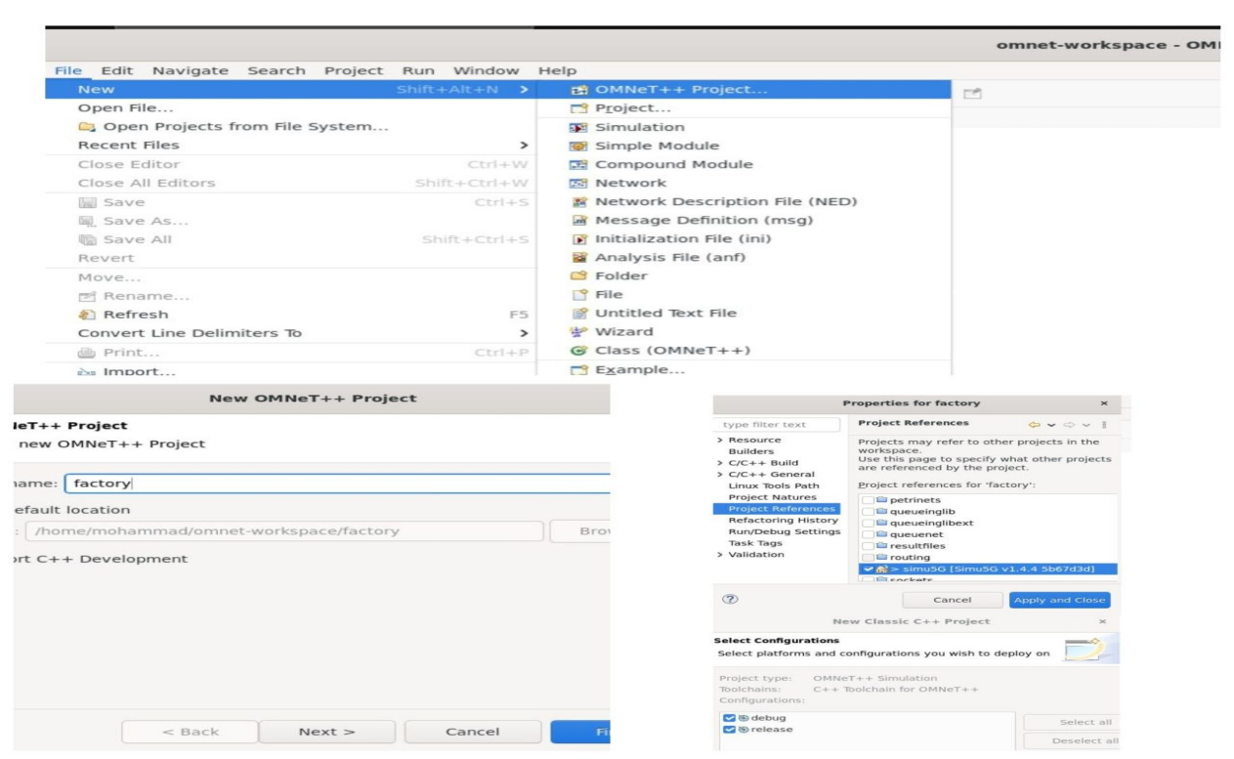
Figure 9

To develop the proposed 5G network simulation for an indoor factory environment (InH-F), the network architecture is first created in OMNeT++. A new OMNeT++ project named “factory” is created, as shown in Figure 10.7.
An empty project is then generated to contain the files required for building, configuring, and running the simulation model. These files include the network topology files, configuration files, source files, and simulation result files.

3.4 Configuration Parameters (Scenario 1 & 2)

3.4.1 Scenario 1: InF-DH & SCS= 30KHz

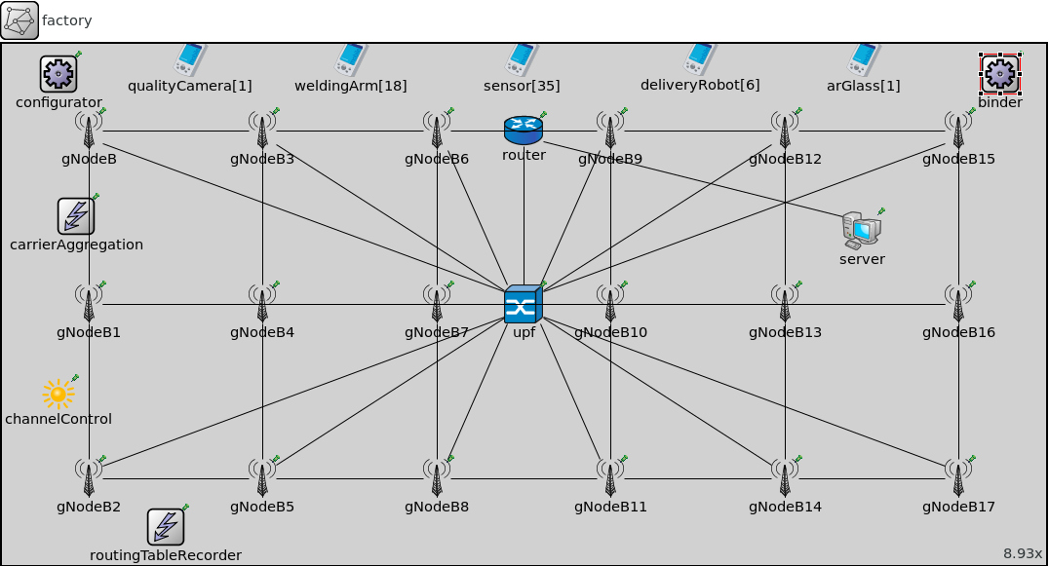
Figure 10.7

3.4.1.1 Configurator: Ipv4NetworkConfigurator
Assigns IPv4 addresses and sets up static routing for an IPv4 network. It assigns per-interface IP addresses, strives to take subnets into account, and can also optimize the generated routing tables by merging routing entries.
IMPORTANT: as of INET 2.2, this module does NOT assign addresses or add routes directly, just stores them in its internal data structures. Network nodes are supposed to contain an instance of ~Ipv4NodeConfigurator (normally part of the network layer compound module) that actually configures the node's interface table and routing table based on the information stored in the global network configurator module.
The configurator supports both manual and automatic address assignment, and their combinations. You can provide address and netmask templates with unspecified parts, and the configurator automatically completes them by trying to put nodes on the same LAN into the same subnet. It also supports manual routes, and automatic routes that follow the shortest paths. By default, the configurator adds default routes where applicable (e.g. in hosts) and does subnet-based routing.
Hierarchical routing can be set up by using only a fraction of configuration entries compared to the number of nodes. The configurator also does routing table optimization that significantly decreases the size of routing tables in large networks.
Most of the above features can be turned on and off using NED parameters. The details (interface address and netmask templates, manual routes, etc.) can be configured in a single XML file for the whole network.
Modules that represent network nodes (host, hub, bus, switch, access point, router, etc.) are expected to have the @networkNode property, because that's how the configurator recognizes them in the model. All nodes must have their interface table (~InterfaceTable module) as their interfaceTable submodule. All routers must have their routing table (~Ipv4RoutingTable module) as their routingTable or networkLayer.routingTable submodule.
By default all interfaces in all nodes will have a unique IPv4 address assigned. Routing tables will be configured so that there's a route following the shortest path from any node to any interface. In other words, all interfaces will be reachable from all nodes (e.g. ping).
The configurator doesn't connect to any other modules (it has no gates), and should have only one instance in the whole model. The configuration takes place in initialization stage 2 after the interfaces are registered in the ~InterfaceTable modules.
The configurator goes through the following configuration steps:
Builds a graph representing the network topology. The graph will have a vertex for every module that has a @networkNode property (this includes hosts, routers, and L2 devices like switches, access points, Ethernet hubs, etc.) It also assigns weights to vertices and edges that will be used by the shortest path algorithm when setting up routes. Weights will be infinite for IP nodes that have IP forwarding disabled (to prevent routes from transiting them), and zero for all other nodes (routers and and L2 devices). Edge weights are chosen to be inversely proportional to the bitrate of the link, so that the configurator prefers connections with higher bandwidth. For internal purposes, the configurator also builds a table of all "links" (the link data structure consists of the set of network interfaces that are on the same point-to-point link or LAN)
Assigns IP addresses to all interfaces of all nodes. The assignment process takes into consideration the addresses and netmasks already present on the interfaces (possibly set in earlier initialize stages), and the configuration provided in the XML format (described below). The configuration can specify "templates" for the address and netmask, with parts that are fixed and parts that can be chosen by the configurator (e.g. "10.0.x.x"). In the most general case, the configurator is allowed to choose any address and netmask for all interfaces (which results in automatic address assignment). In the most constrained case, the configurator is forced to use the requested addresses and netmasks for all interfaces (which translates to manual address assignment). There are many possible configuration options between these two extremums. The configurator assigns addresses in a way that maximizes the number of nodes per subnet. Once it figures out the nodes that belong to a single subnet it, will optimize for allocating the longest possible netmask. The configurator might fail to assign netmasks and addresses according to the given configuration parameters; if that happens, the assignment process stops and an error is signaled.
Adds the manual routes that are specified in the configuration.
Adds static routes to all routing tables in the network. The configurator uses Dijkstra's weighted shortest path algorithm to find the desired routes between all possible node pairs. The resulting routing tables will have one entry for all destination interfaces in the network. The configurator can be safely instructed to add default routes where applicable, significantly reducing the size of the host routing tables. It can also add subnet routes instead of interface routes further reducing the size of routing tables. Turning on this option requires careful design to avoid having IP addresses from the same subnet on different links. CAVEAT: Using manual routes and static route generation together may have unwanted side effects, because route generation ignores manual routes.
Then it optimizes the routing tables for size. This optimization allows configuring larger networks with smaller memory footprint and makes the routing table lookup faster. The resulting routing table might be different in that it will route packets that the original routing table did not. Nevertheless, the following invariant holds: any packet routed by the original routing table (has matching route) will still be routed the same way by the optimized routing table.
Finally, it dumps the requested results of the configuration. It can dump network topology, assigned IP addresses, routing tables, and its own configuration format.

The following example configures all interfaces in the IPv4 address range 10.0.0.0 - 10.255.255.255, and netmask range 255.0.0.0 - 255.255.255.255. This is the default configuration.
3.4.1.2 CarrierAggregation:
Implements the Carrier Aggregation (CA) functionality used at the Medium Access Control (MAC) layer of e/gNodeBs and UEs. CA allows multiple frequency bands - referred to as Component Carriers (CCs) - to be aggregated in order to increase the overall available bandwidth of the system. Each CC is implemented as a submodule and can be configured independently from each other. e/gNodeB and UE can be configured to use one or more CCs among those configured in this module. There must be one (and only one) instance of this module in the network.
3.4.1.3 ChannelControl:
Utility module that records the position of each radio module in the network. Exactly one instance of this module (or its derived extensions) must be present in the network. Note that channel parameters in this module are obsolete and are not utilized.
3.4.1.4 RoutingTableRecorder:
Records changes in the routing tables (~Ipv4RoutingTable) and interface tables (~InterfaceTable) of all hosts and routers. The filename has to be specified in the routinglog-file configuration option that this module registers.
3.4.1.5 Binder Module
3.4.1.6 Router:
A network router device with support for multiple routing protocols and network interfaces. Provides the foundation for simulating various types of routers in both wired and wireless networks.
The Router module extends ApplicationLayerNodeBase with routing protocol support, including OSPF, BGP, RIP, PIM, and EIGRP. It has packet forwarding enabled by default and can be configured with various interface types.
3.4.1.7 Upf:
Implements the 5G Core User Plane Function (UPF).
The UPF is responsible for packet routing and forwarding, packet inspection, and (de)tunneling according to GTP. The core network can contain multiple UPFs. Intermediate UPFs, which are not connected to an external Data Network, act like IP routers in the current version. Allows the connection of mobile terminals to external data networks or other 5G network elements through GTP tunneling.
3.4.1.8 Server: Standard Host
A comprehensive model of an IPv4/IPv6 host that provides a complete network stack with configurable application, transport, network, and link layers. It supports multiple network interfaces, protocols, and applications that can be customized through parameters.
3.4.1.9 : gNodeB:
Implements a gNodeB for a 5G network. It extends the ~eNodeB module by providing 5G connectivity to ~NrUe modules. It can be used in either StandAlone (SA) or Non-StandAlone (NSA) 5G deployments. In the former case, it is directly connected to a ~Upf module. In the latter case, this module can be configured as a secondary node of a ~eNodeB module, thus enabling E-UTRA Dual Connectivity (EN-DC).
3.4.1.10 qualityCamera[1]: NrUe
Models a User Equipment (UE) for a 5G/LTE network. It extends the ~LteUe module by implementing a ~NrNicUe as a Network Interface Card (NIC) module. This module can be used to model a device that can connect to either a 4G eNodeB or a 5G gNodeB, or both.
3.4.1.11 weldingArm[18]: NrUe
Models a User Equipment (UE) for a 5G/LTE network. It extends the ~LteUe module by implementing a ~NrNicUe as a Network Interface Card (NIC) module. This module can be used to model a device that can connect to either a 4G eNodeB or a 5G gNodeB, or both.

In conclusion, this chapter detailed the simulation methodology, including the selection of OMNeT++ with Simu5G, the topology design for an indoor factory environment, and the configuration of two scenarios with different subcarrier spacings. The traffic models and performance metrics defined here form the basis for the results and analysis presented in the next chapter.
The simulation employs three traffic models to evaluate different aspects of network performance. Static device traffic represents fixed industrial sensors and equipment communicating with constant bit-rate UDP applications. Mobile device traffic models delivery robots and AGVs that move within the factory floor, testing handover performance and mobility management. TCP application traffic simulates data-intensive applications such as quality camera video streams and file transfers, evaluating throughput, congestion control, and end-to-end latency under realistic transport-layer conditions.
3.4.2- OMNeT++ Simulation Configuration (omnetpp.ini):
The omnetpp.ini file is the main configuration file of the simulation. It defines the factory network scenario, simulation duration, 5G radio parameters, carrier aggregation settings, mobility models, application traffic, and output recording options. It allows different simulation scenarios to be executed without modifying the network topology.
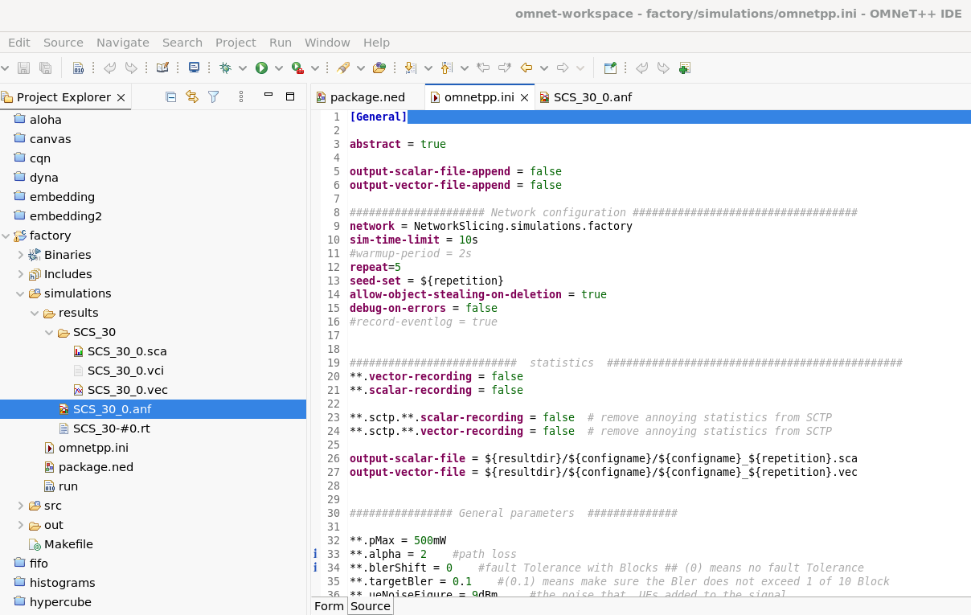
Figure 11

Chapter 4
Results, Analysis, and Recommendations

This chapter presents the simulation results and analysis across three traffic models: static devices, mobile devices, and TCP applications. It compares performance between the two configured scenarios, discusses key findings, and provides recommendations for future work, concluding with a summary of the project outcomes.

4.1 Scenario 1: InF-DH & SCS= 30KHz

4.1.1 Results and Analysis (Static Devices)
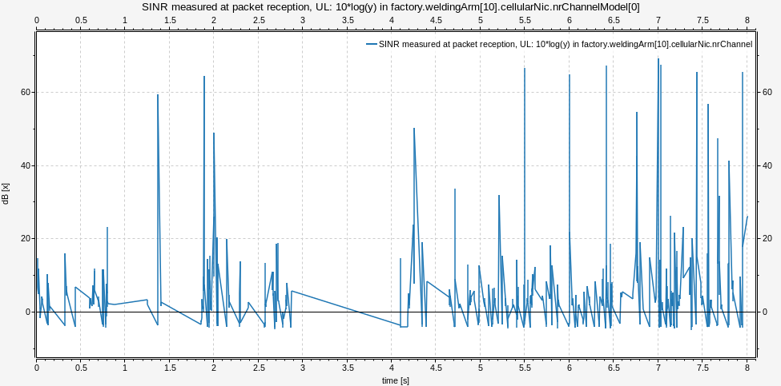

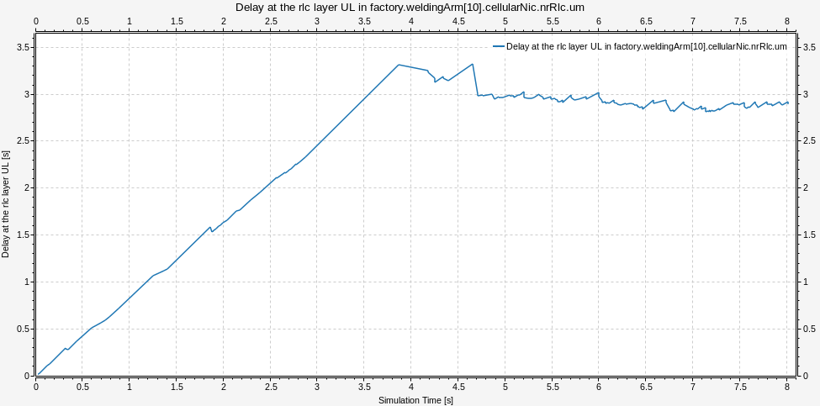
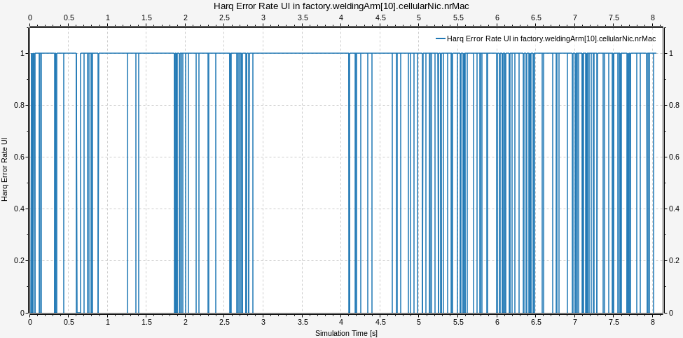
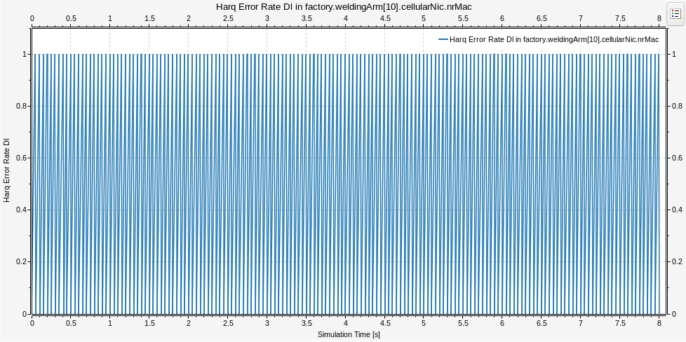
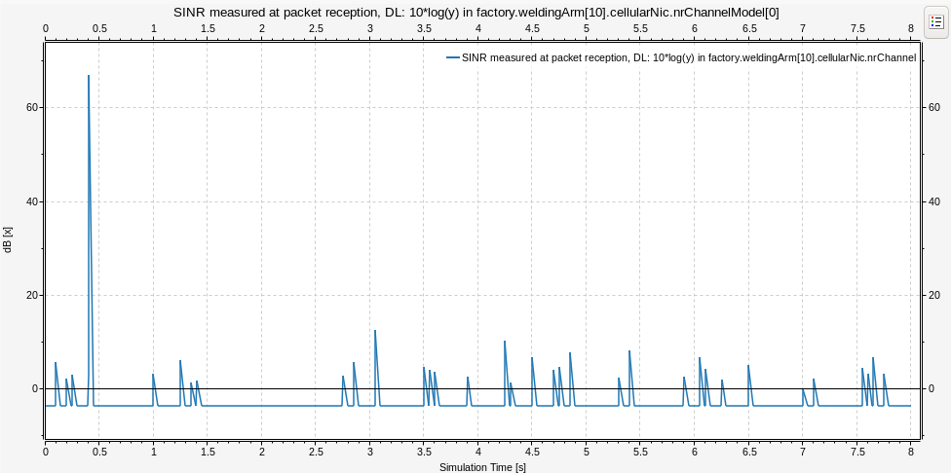
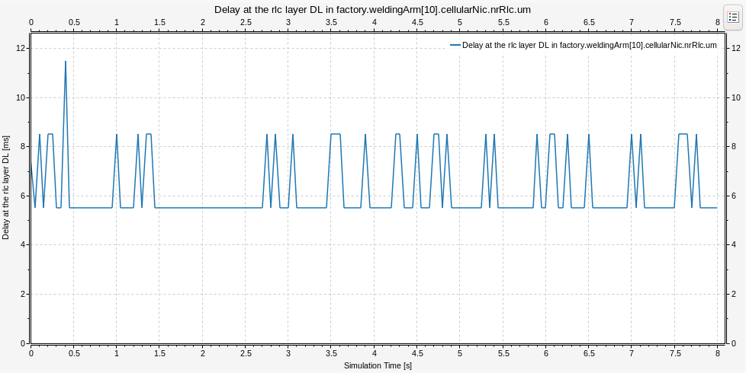

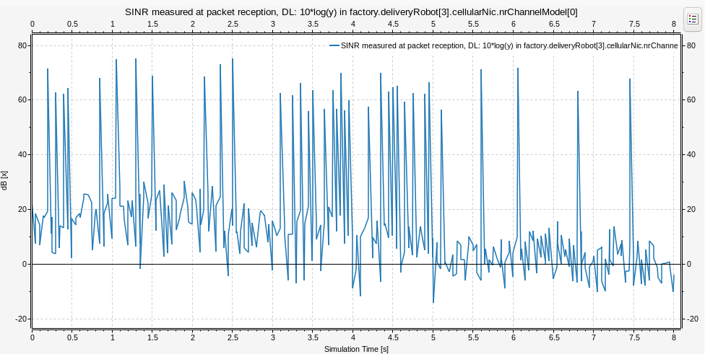
4.1.2 Results and Analysis (Mobile Devices)
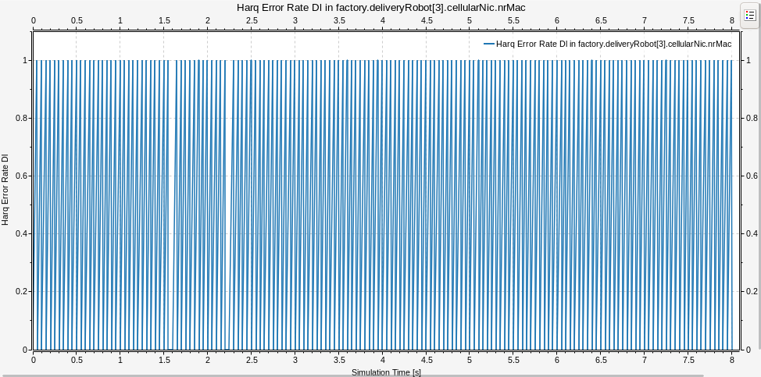
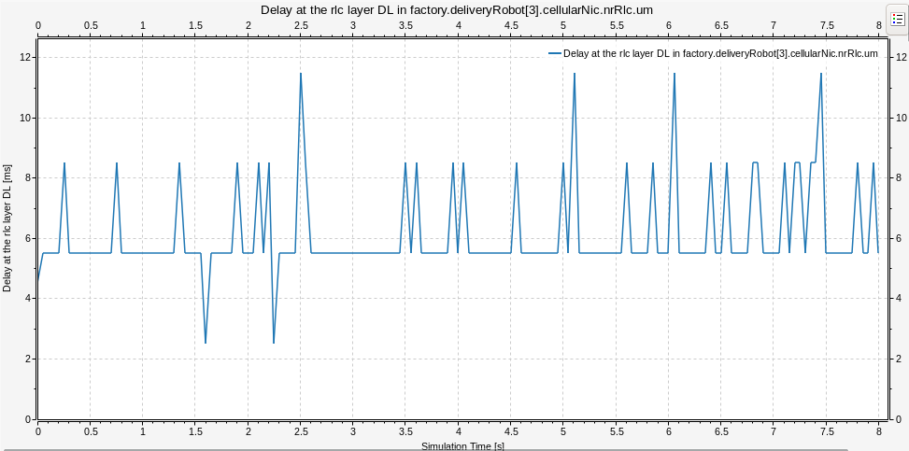

4.2 Scenario 2: InF-DH & SCS= 60KHz

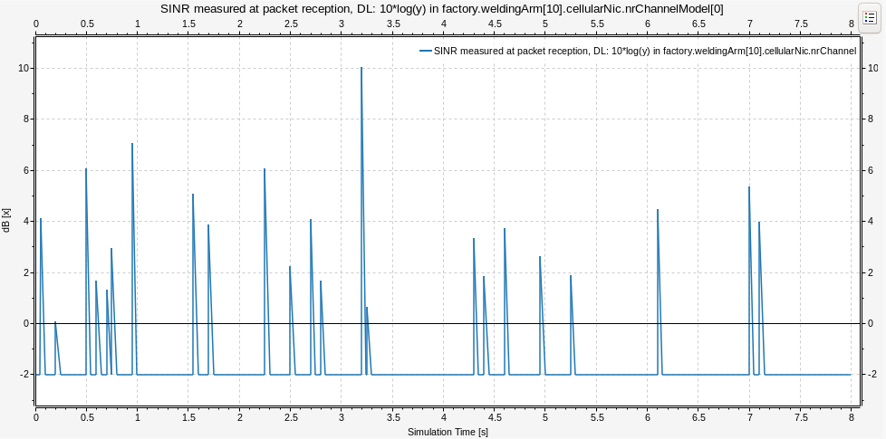
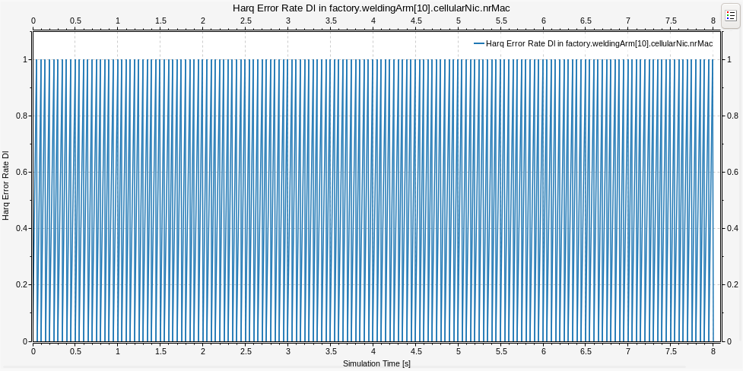
4.2.1 Results and Analysis (Static Devices)
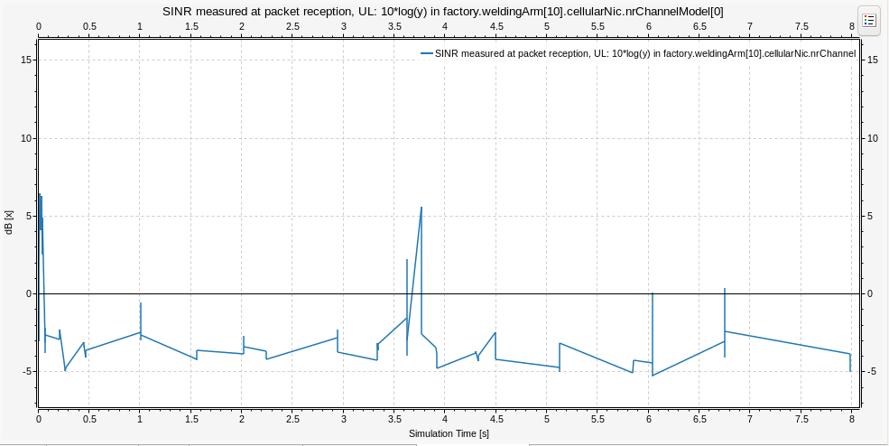
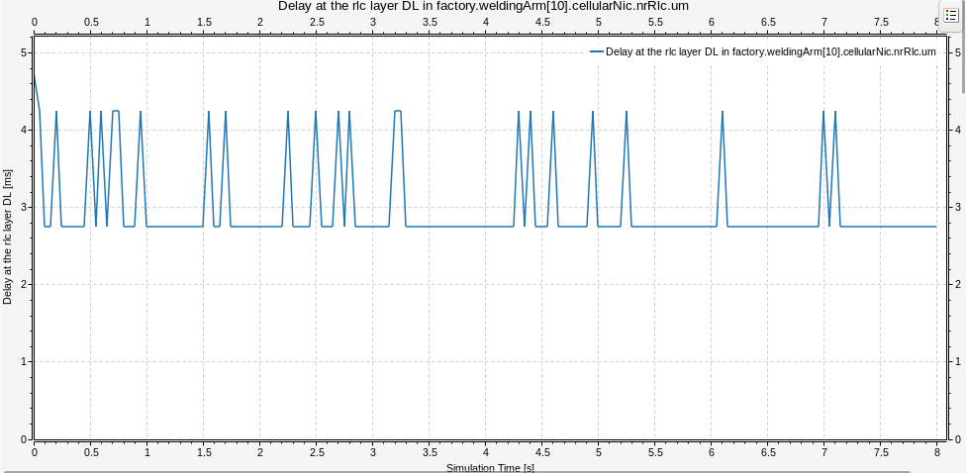
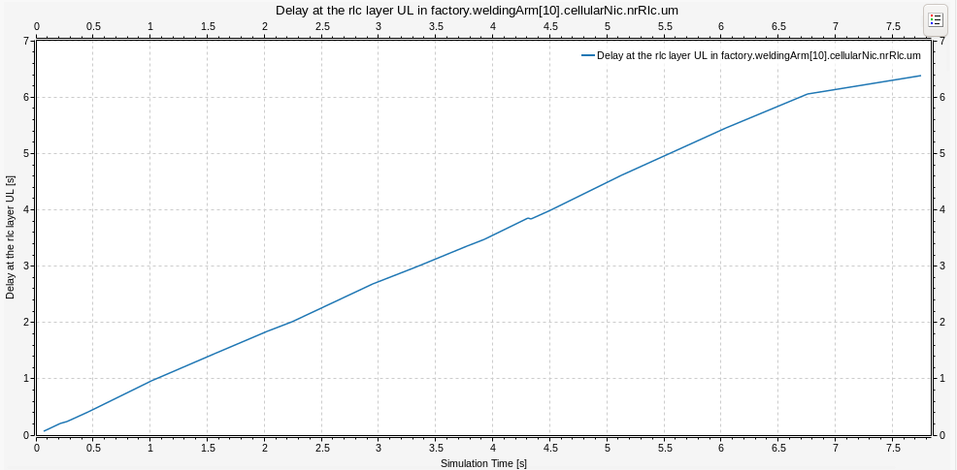
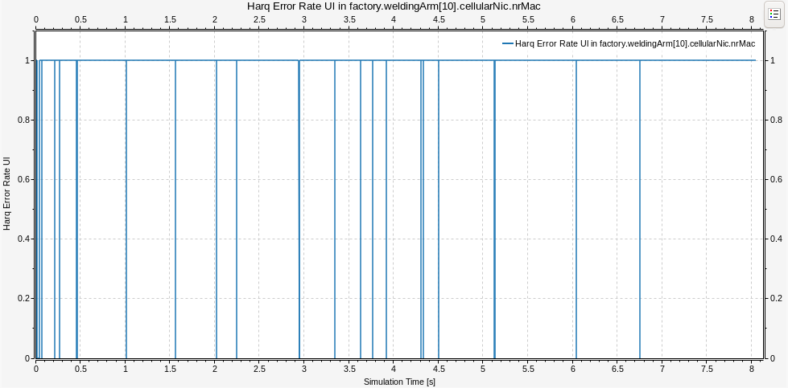

4.2.2 Results and Analysis (Mobile Devices)
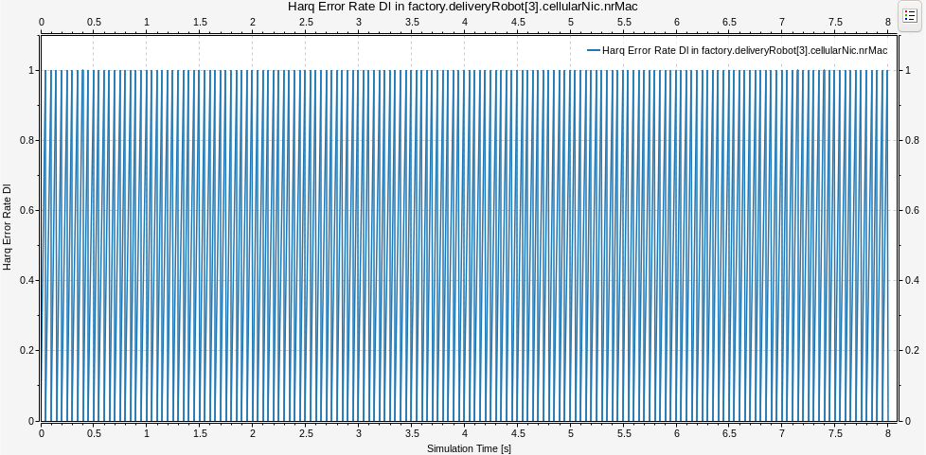
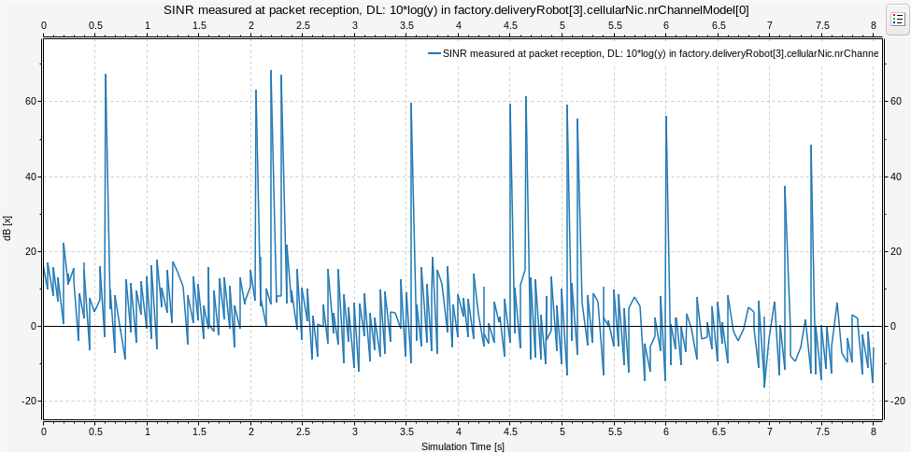
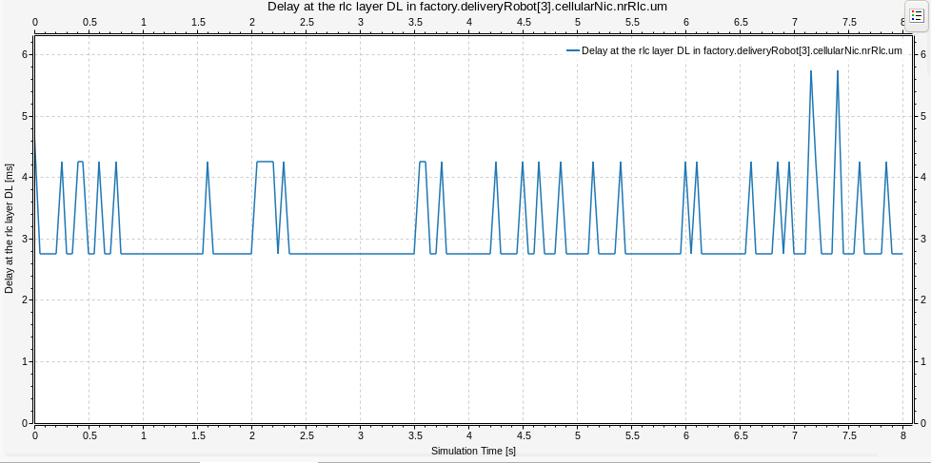

4.4 Comparison and Discussion
The comparison between Scenario 1 (SCS=30 kHz) and Scenario 2 (SCS=60 kHz) reveals trade-offs between throughput, latency, and reliability. Higher subcarrier spacing reduces symbol duration, enabling lower latency but potentially increasing overhead. Static devices exhibit stable performance with consistent throughput and minimal packet loss, while mobile devices demonstrate the impact of handover events and Doppler effects on connection stability. TCP applications show how congestion control interacts with the 5G radio layer, affecting end-to-end throughput and latency under different numerology configurations.

4.5 Recommendations and Future Work
Based on the simulation results, it is recommended to adopt 30 kHz SCS for latency-sensitive industrial applications and 60 kHz SCS for throughput-intensive scenarios. Future work should explore advanced network slicing algorithms, integrate machine learning for dynamic resource allocation, extend the simulation to multi-cell scenarios with inter-cell interference, and evaluate the impact of MEC placement on end-to-end performance for URLLC applications.

4.6 Conclusion
This project demonstrated the design and evaluation of a 5G network simulation for industrial factory environments using OMNeT++ and Simu5G. The results across static, mobile, and TCP traffic models provide insights into the performance characteristics of different 5G configurations, contributing to the understanding of 5G network optimization for Industry 4.0 applications.

References
[1] Ochonu, Regina, and Josep Vidal. "Slice-aware resource allocation and admission control for smart factory wireless networks." 2024 IEEE 100th Vehicular Technology Conference (VTC2024-Fall). IEEE, 2024.
[2] Zanbouri, Kouros, Md Noor-A-Rahim, and Dirk Pesch. "Scalability Analysis of 5G-TSN Applications in Indoor Factory Settings." 2025 IEEE Wireless Communications and Networking Conference (WCNC). IEEE, 2025.
[3] Rafique, Wajid, et al. "A survey on beyond 5g network slicing for smart cities applications." IEEE Communications Surveys & Tutorials 27.1 (2024): 595-628.
[4] 3GPP TR & TS Documents

